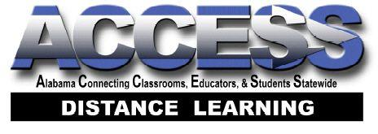
Did you know?
Alabama Connecting Classrooms, Educators, and Students Statewide (ACCESS) offers all of the following and …

It is ABSOLUTELY FREE!
- Supplemental and blended courses available to ALL 8-12 Alabama schools
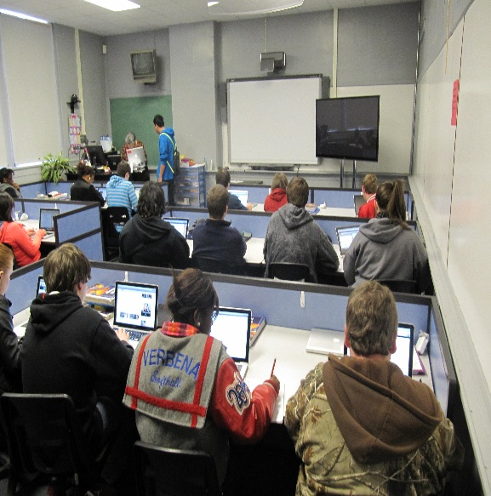
- Credit Recovery – 22 core courses
- Materials/Resources embedded in course content*
- Certified, highly-qualified teachers
- All courses aligned to current Alabama standards
- NCAA compliant – 51 courses approved for eligibility purposes
- No limits placed on the number of courses a student may take**
- Students can earn all credits needed for their high school diploma***
- Students remain enrolled with their local school and
- Continue to participate in extra-curricular activities (clubs, sports, social events)
- Earn their credits from their local school
- Receive their diplomas from their local district
Want to start your own virtual school? ACCESS can help!
Do… | Don’t…
Determine the purpose and decide on leadership | Choose content without teacher support
Choose content or courses from ACCESS (95 courses) | Choose curriculum not aligned with state standards
Assess your equipment needs | Select & purchase equipment that does not meet your needs
Establish accountability measures (absences, failures, etc.) | Let accountability slide
Make courses interactive, engaging, and rigorous if it is district developed | Create or purchase courses that do not challenge students academically
Decide on a location (on-campus, off-campus) | Ignore total costs
Determine whether you will use ACCESS teachers or district teachers and provide face-to-face support | Neglect what best suits your types of students and your community needs
For more information log on to accessdl.state.al.us or call 334-242-9594.

*A textbook is required for AP courses.
**When, where, and how many courses a student takes is determined by the local school/system.
***Except for Career Preparedness (Available Fall 2016).

