2020-2021 Web-Based Courses with Materials List
ACCESS Course Title | Textbook Publisher | Textbook |  | Other Materials
AP Art History  AP Biology  v13  AP Biology cont. | Pearson Education  Florida  Virtual* | No text required  Mastering Biology Custom eBook (customized for FLVS course) * |  | AP Art History Framework  The AP Art History Framework is a free material provided by College Board that outlines the three big ideas, three essential questions, twelve learning objectives, and ten content areas taught within the AP Art History course.  Recommended Materials-  Art through the Ages Global History, 14th Edition. Fred S. Kleiner  Art History, 4th Edition. Marilyn Stokstad and Michael Watt Cothren  Household materials used in AP Biology labs provided by the students.  Segment One Required Lab Materials  Lesson 1.03  - 125 Light-Colored Beans and 50 Dark-Colored Beans (or you can use two colors of Candy)  - Calculator  - Graph Paper  Lesson 2.03  - 6 large Plastic Cups or Bowls  - Aluminum Foil or Plastic Wrap  - Knife (to cut the potato/fruit)  - Metric Ruler  - Paper Towel  - 2 Water-tight Zip-lock Plastic Sandwich Bags  - Measuring Cups and Spoons  - 1 Potato : choice of one of the following: Sweet Potato, Pear, or Apple  - 60 g or 5 Tablespoons (Tbs.) Sucrose (Table Sugar)  - 100 mL Distilled Water (from the grocery store)  - Iodine (can be obtained at a discount or drug store)  - Starch Solution: Options for creating solution: Option 1. Add ¼ cup cornstarch and ¼ cup water into a bowl. Stir to mix. Add 1 to 1½ cups very warm water (be very careful when working with hot water) and stir well. Option 2. Boil a small potato in 1 cup of water, then mash the potato. After the potato cools, pour water over the mashed potato and strain the fibrous part out using a coffee filter. Cool to room temperature to avoid adding temperature as a variable.  Lesson 3.04  - Glass Cup or Bowl  - Hole Puncher or Plastic Drinking Straw  - Tap Water  - Liquid Dish Soap  - Timer or Clock with a Second Hand  - Lamp (with 60-watt or higher light bulb)  - Metric Ruler  - Baking Soda (sodium bicarbonate, NaHCO3)  - Leaf from a Living Plant (flexible, without a waxy covering- such as fresh spinach)  - Plastic Syringe (10 mL or larger, without needle—can be purchased at a drug store)  Segment Two Required Lab Materials  Lesson 5.01 - Student Selection of Materials to Model Mitosis  - Choice of: Clay, Pipe Cleaners, or other Objects  - Camera to Capture an Image of the Model Created  Lesson 6.05  - 15 Pill Bugs [contact your instructor if you wish to use an alternate animal(s) or if you need assistance locating pill bugs]  - 2 Shoe Boxes to make a Choice Chamber  - Scissors  - Tape  - Watch with a Minute Hand and a Second Hand  - Filter Paper or Paper Towels  - Water  Lesson 7.04  - Cemetery (or access to cemetery records)  - Calculator  - Pencil or Pen  - Paper
AP Calculus AB  v14 | Study Forge  Florida Virtual* | StudyForge – Calculus AB/BC/Honors v14 (videos) ** |  | Required:  Students are required to have a graphing calculator. The course recommends a TI-83 or a TI-84, and contains instructions for these calculators at various key points, as well as how to use the calculator under certain circumstances.
AP Computer Science A  v17 | iMacs  Java | ***Provided by the Alabama State Department of Education***  AP Computer Science – IMACS Course Material |  | AP Computer Science: Java Programming: an introductory computer science course leading to the College Board's Advanced Placement Computer  Science A exam.  Be Prepared for the AP Computer Science Exam: An online, interactive edition of the popular review course for the College Board Advanced Placement Examination in Computer Science in Java.  https://www.eimacs.com/educ_bpcsoverview.htm
AP English Language and Composition |  | No text required |  | Required: Students will need to purchase or borrow the books from their school or public library (per course resources).  Module 1  The Crucible by Arthur Miller  Module 4  Choose one of the following:  Zen in the Art of Writing by Ray Bradbury  On Writing Well by William Zinsser  Module 6  Their Eyes Were Watching God by Zora Neal Hurston  Module 7  Choose one of the following:  Hunger of Memory by Richard Rodriguez  A Long Way Gone: Memoirs of a Boy Soldier by Ishmael Beah  Angela’s Ashes by Frank McCourt  The Woman Warrior by Maxine Hong Kingston  Reading Lolita in Tehran by Azar Nafisi  One Writer's Beginning by Eudora Welty  Module 8  Choose one of the following:  Three Cups of Tea by Greg Mortenson  Nickel and Dimed by Barbara Ehrenreich  Atomic Farmgirl by Teri Hein  Fast Food Nation by Eric Schlosser  Optional: It is recommended they purchase a copy of Fast Track to a 5: Preparing for the English Language and Composition Examination and/or 5 Steps to a 5 AP English Language, Second Edition.
AP English Literature and Composition |  | No text required |  | You need to supply the following materials. You can borrow from your public library or rent from your local video store.  - Frankenstein by Mary Shelley  - The Hollow Men” by T. S. Eliot  - A novel from the list provided in Module 2  - Heart of Darkness by Joseph Conrad  - Wuthering Heights by Emily Bronte  - Grapes of Wrath by John Steinbeck  - Hamlet by William Shakespeare  - Hamlet video (Versions available: Mel Gibson, Kenneth Branagh, Laurence Olivier) **  - The Awakening by Kate Chopin  - The Importance of Being Earnest video **  - Barron's How to Prepare for the AP Advanced Placement Exam English Literature and Composition  - Death of a Salesman by Arthur Miller  You will also need to provide one of the following books for the module 9 Pot Luck Dinner Party assignments:  - Things Fall Apart by Chinua Achebe  - A House Made of Dawn by Scott Momaday  - Cry, the Beloved Country by Alan Paton  - Othello
AP  Macroeconomics |  | No text required. | None
AP Psychology | Pearson Education  Florida Virtual * | AP Edition Psychology: Cicarelli and White 2011 custom eText (customized for FLVS course)  Pearson Education*
AP Statistics | W.H. Freeman and Company | ***Not available through FLVS Storefront***  The Practice of Statistics: TI-83/89 Graphing Calculator Enhanced 2nd Edition (2003); ISBN-13: 978-0716747734  OR  The Practice of Statistics 4th Edition (2012);  ISBN-13: 978-1429245593;  ISBN-10: 142924559X | TI-83/89 Graphing Calculator
AP  United States  Government and Politics v18 | W.W. Norton  Florida Virtual * | Ginsberg, B., Lowi, T. J., Weir, M., Tolbert, C. J., & Spitzer, R.J. We the People: An Introduction to American Politics. Twelfth Essentials Edition.  New York: W.W. Norton & Company, 2019.*
AP United States History v16 | W.W. Norton  Florida Virtual * | Give Me Liberty: An American History eText  W.W. Norton*

Notes: Receiving schools will provide materials for all of the above courses. Schools should check with contact vendors at the time of purchase for the most current cost. Instructions for ordering from the Florida Virtual School (FLVS) storefront are provided below.

* eBook/Text is customized for the FLVS course that ACCESS uses. This item should be ordered from the FLVS storefront to assure the correct item is received in a timely fashion.

Please contact Dr. Scherrie B. Pickett if you have questions. Phone: (334) 694-4641, Email: scherrie.banks@alsde.edu

How to Order Storefront Materials
1. Go to: https://materials.flvsgl.com/
2. Register by clicking on the links outlined below:
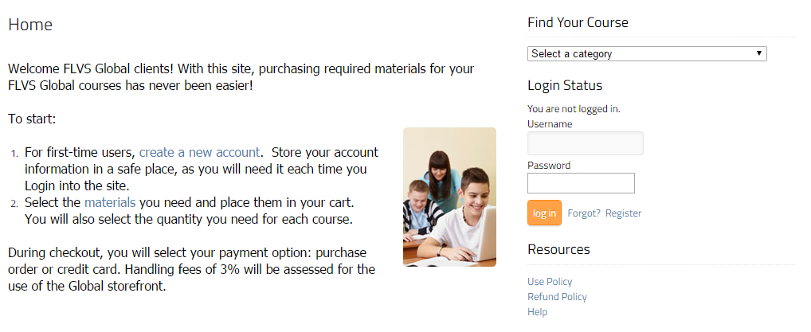
3. Once you have successfully registered, make sure you are logged into your account and click “Shop.”
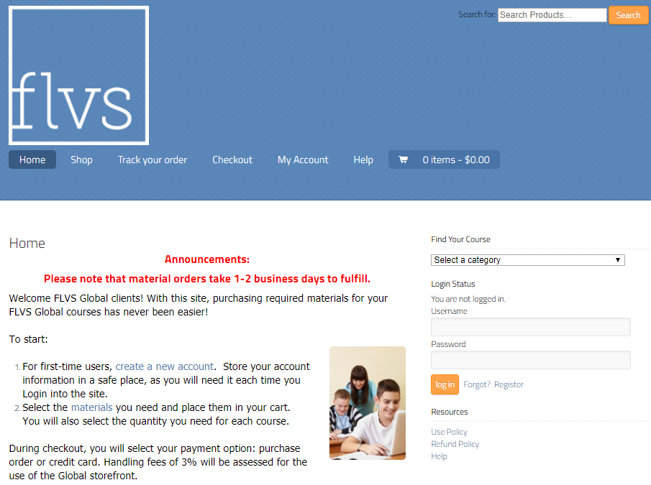

4. On the shop page, you will see the course materials available for order. Add the products to the cart that you wish to order.
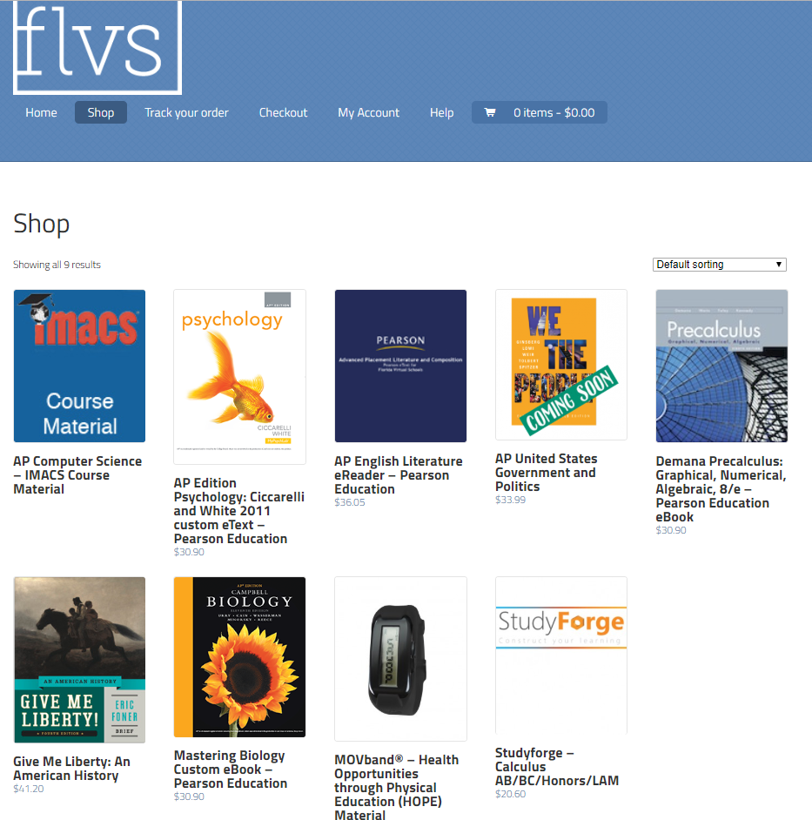
5. When you have successfully chosen all your product(s) by clicking on the icon(s), click “Checkout” in the navigation bar.
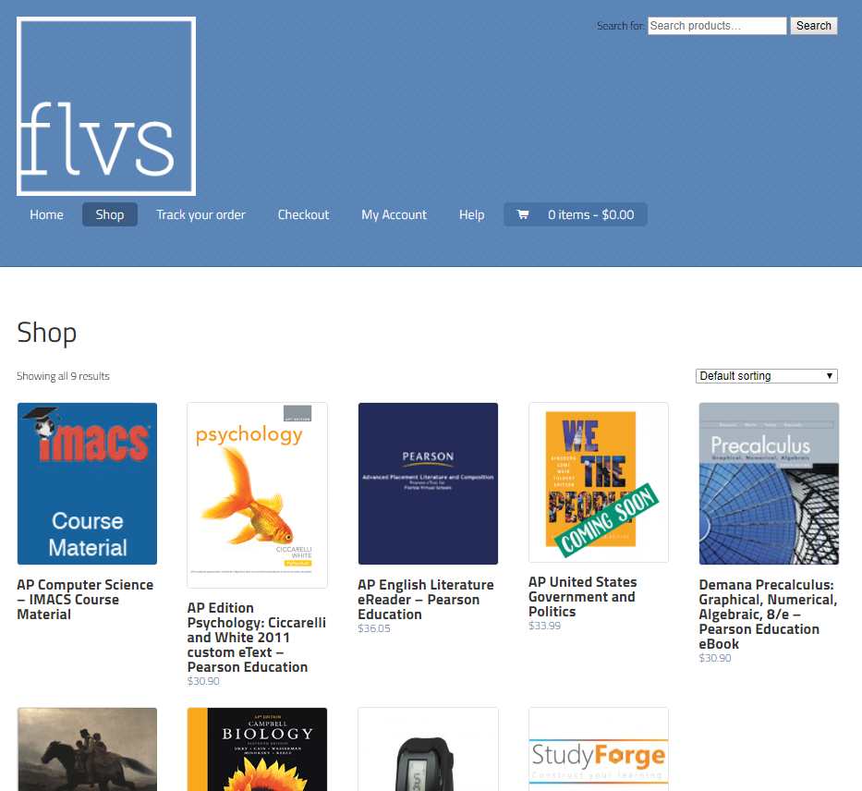
6. Enter your billing information, select your content provider, and choose payment method for the materials; we accept major credit cards and purchase orders.

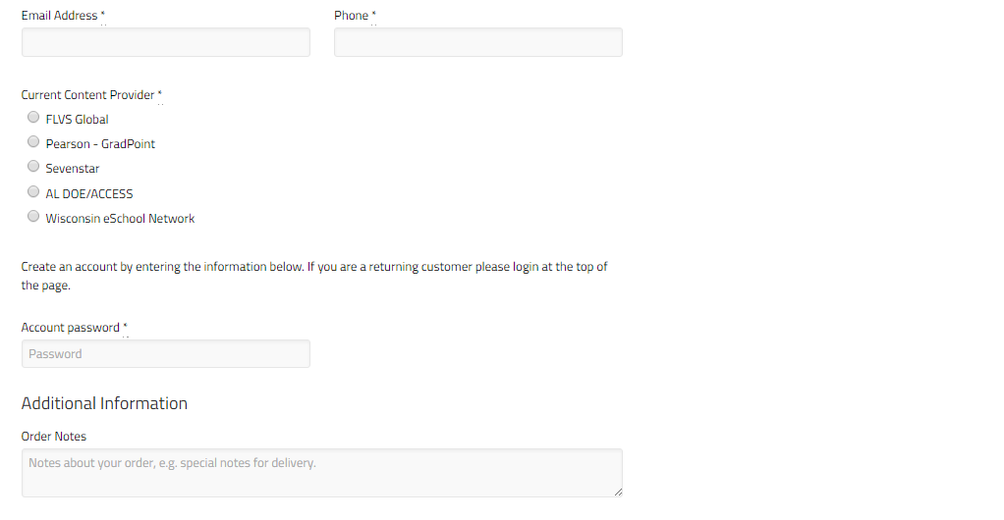
Be sure to click this content provider to make
sure that it will work for ACCESS in D2L.
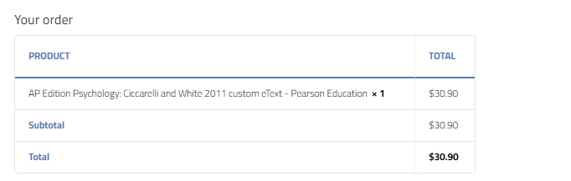
(Next you will need to choose your method of payment)
- If you choose School Purchase Order, follow the directions.
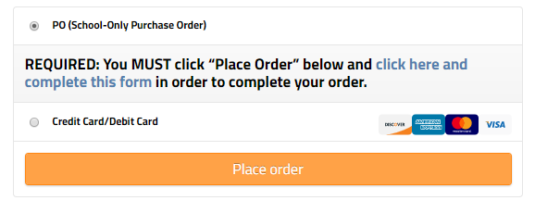
- If you choose Credit Card, Fill in the information requested, then “Place Order.”
