**Name:**

**Date:**

**School:**

**Facilitator:**

7.01 Age of Metternich

### **Using the information from this lesson and the two maps provided for you, please answer the following questions related to the Age of Metternich.**

## Western Europe under the Rule of Napoleon

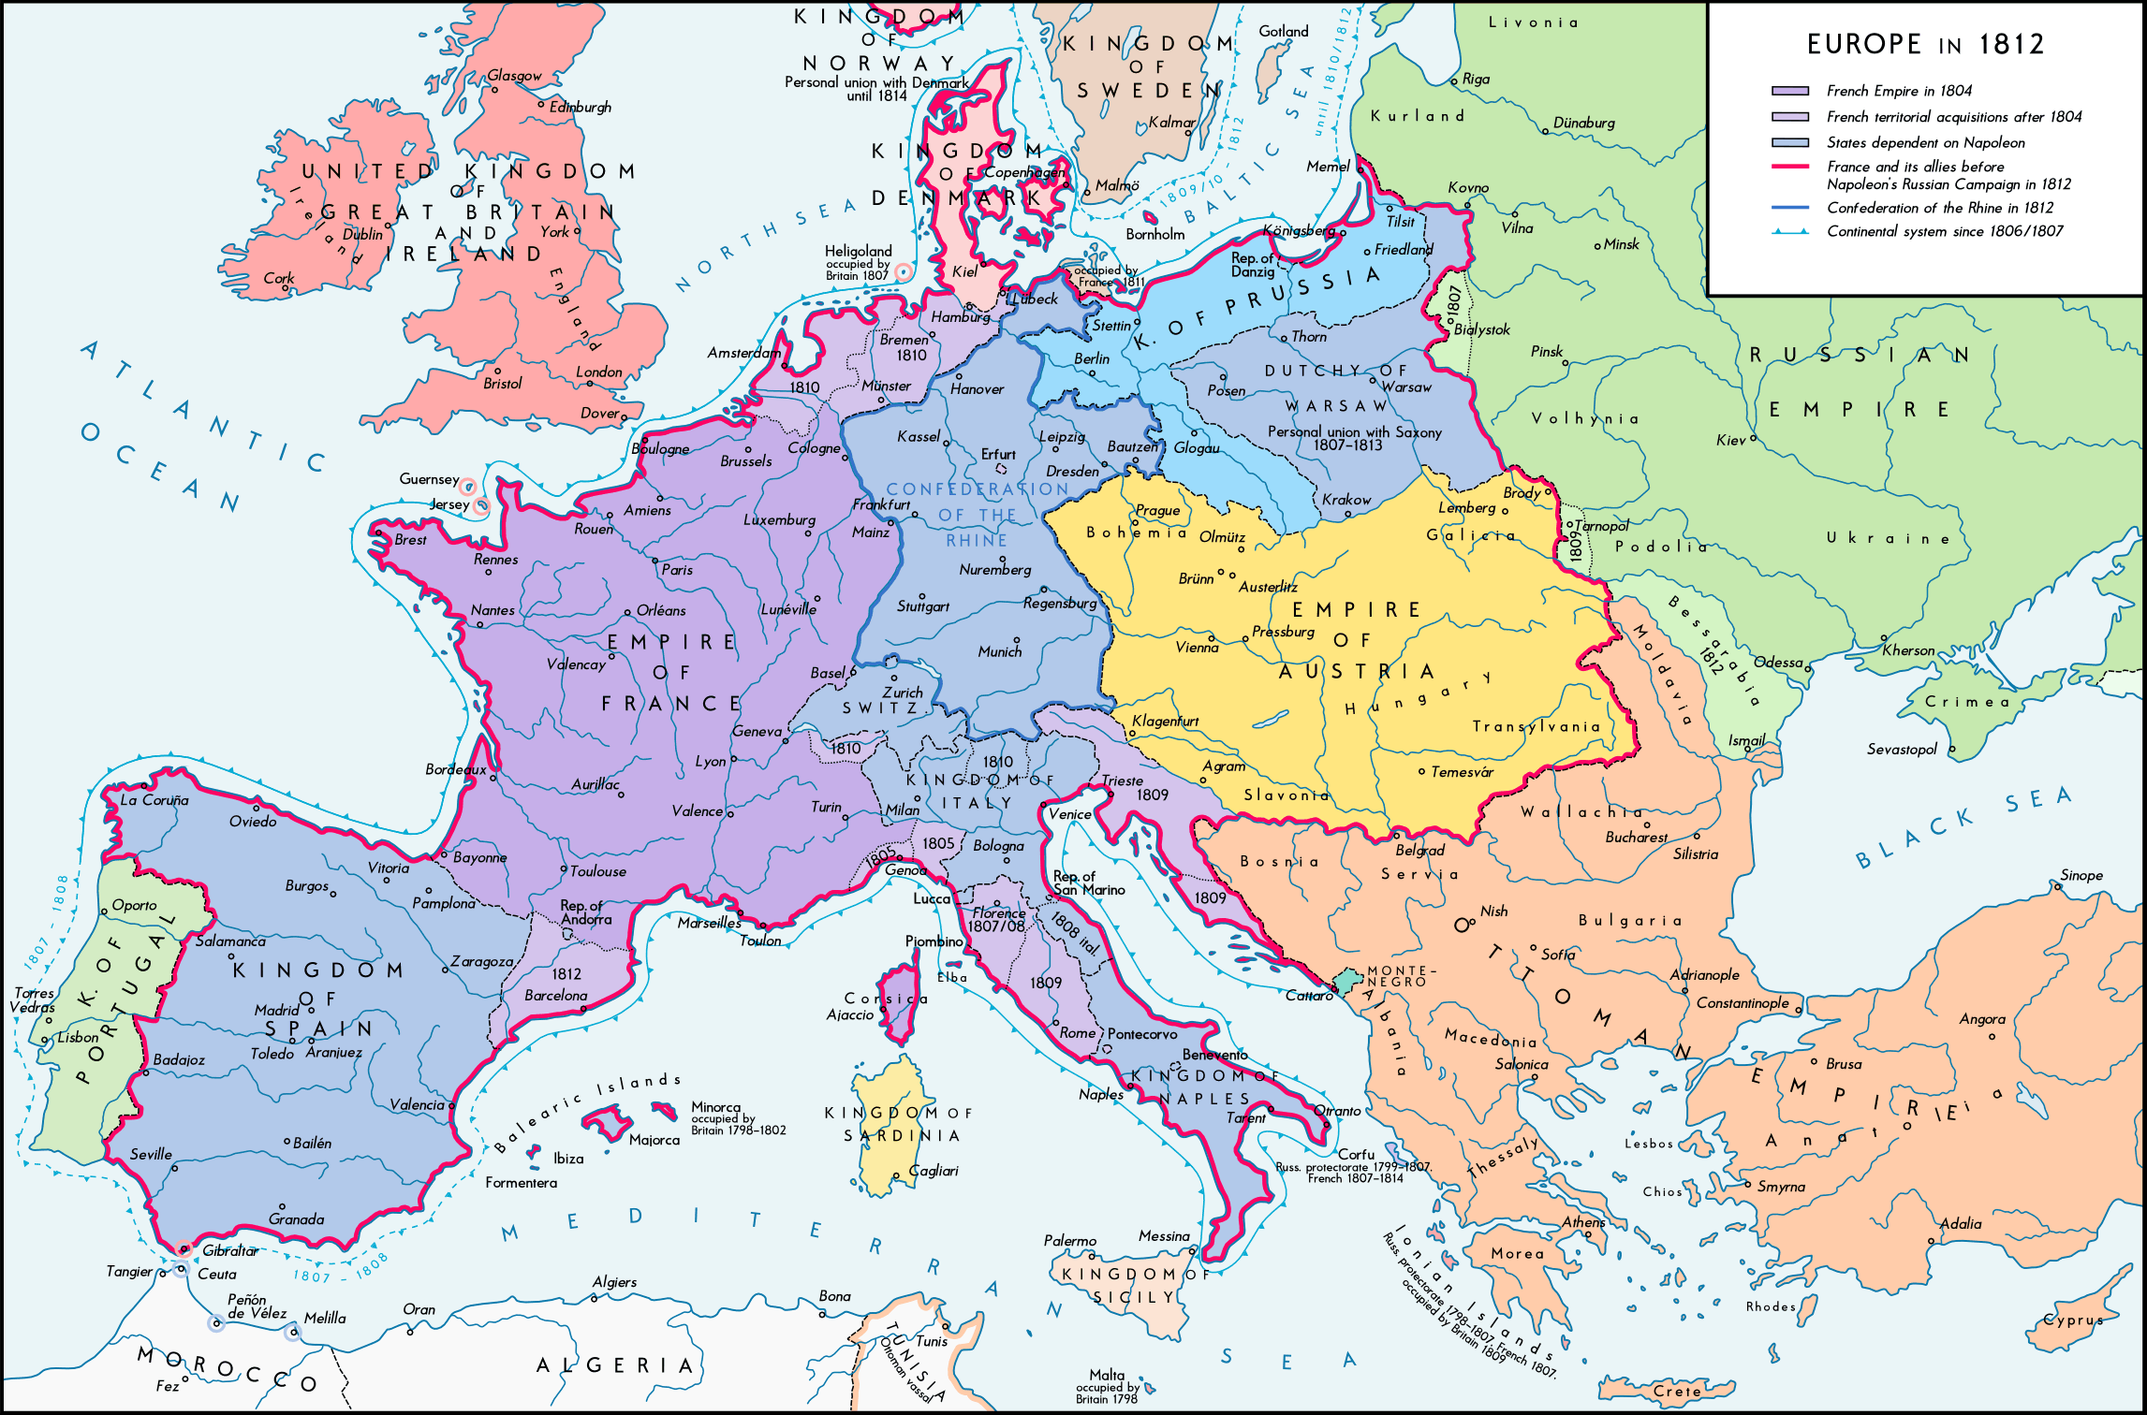



## Europe after the Congress of Vienna

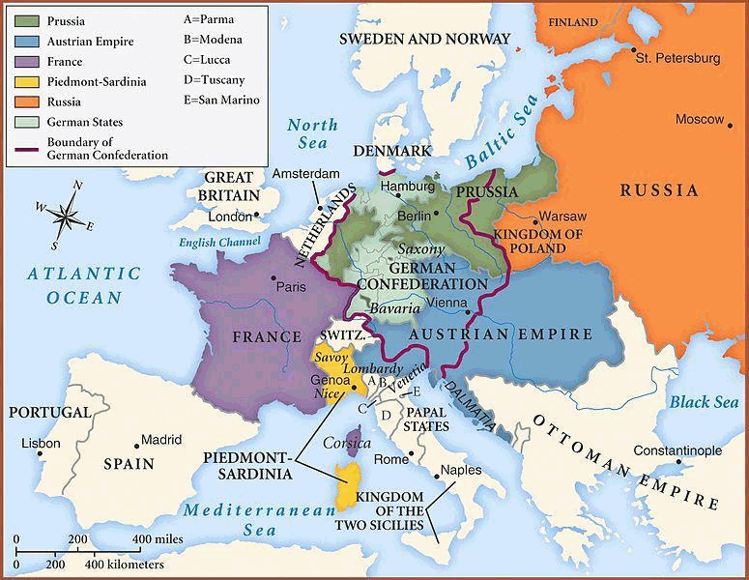

1. Use the map of Western Europe under the Rule of Napoleon to describe the size of France during the reign of Napoleon.

2. According to the map of Western Europe under the Rule of Napoleon, name the five areas (European states) that were under Napoleon’s control.

a.

b.

c.

d.

e.

3. According to the map of Western Europe under the Rule of Napoleon, what empire was allied to Napoleon?

4. Name the states that made up the Quadruple Alliance at the Congress of Vienna.a.

b.

c.

d.

5. Who were the individual leaders at the Congress of Vienna? a.

b.

c.

d.

6. What was the goal of the Congress of Vienna?

7. Describe the territorial adjustments that were made at the Congress of Vienna.

8. How were the German states reorganized at the Congress of Vienna?

9. To what extent were the Big Four successful in reestablishing peace and stability in Europe after 1815? Think about whether or not there were continued conflicts between or within countries to answer this question.