Name:
Date:
School:
Facilitator:

2.02 Preventing Injury
Total Points: 64

Instructions
For each of the following scenarios, identify the hazard and then use image of the pyramid below and on the 2.02 task page to help you make suggestions on how to control the hazard and prevent injuries. An example of how to complete this task is done for you.
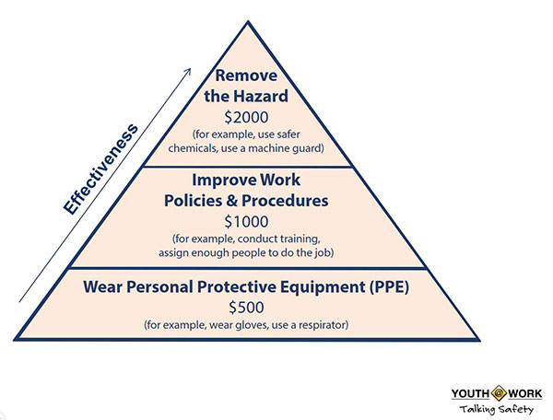

Example
You work in a grocery store as a shelf stocker on the weekends. You are stocking shelves when you notice that a mother who is shopping isn’t watching her two-year old in the buggy as he pulls a jar of pickles off the shelf. The jar falls to the floor and bursts.
- What should you do now?
- What can be done to control the hazard in the future?
What was the hazard? The hazard is the broken glass and liquid now on the floor.
Remove the hazard: While you can’t stop selling pickles at the grocery store, you can check to make sure the customer is not hurt, put out a safety sign until you can clean up the spill and the glass, and notify the manager of the spill.
Improve policies and procedures: Suggest that the pickles be moved to a different shelf that isn’t eye level with a child in a buggy.
Wear personal protective equipment: Make sure you have on the right type of shoes to avoid falling yourself. Use gloves when cleaning up the spill to help keep glass and the pickle juice from coming in contact with your skin.

Situations Involving Hazards
Scenario 1
Tammy is a 16-year-old who works in a fast food restaurant. One day, Tammy slipped on the greasy floor. To catch her fall, she tried to grab a bar near the grill. Tammy missed the bar and her hand touched the hot grill instead. She had to go to the hospital to be treated for a burn and was unable to wait tables until she healed. What was the hazard? What can be done to control the hazard in the future?
What was the hazard?
Remove the hazard:
Improve policies and procedures:
Wear personal protective equipment:

Scenario 2
Will is a 17-year-old who works in a grocery store. One day while unloading a heavy box from a truck, he felt a pain in his lower back. Will tried to keep working. His back kept bothering him, so he finally went to the doctor. Will had to miss work for a week. His back still hurts sometimes. What was the hazard? What can be done to control the hazard in the future?
What was the hazard?
Remove the hazard:
Improve policies and procedures:
Wear personal protective equipment:

Scenario 3
Sheldon is a 16-year old in good physical shape who works for the city cutting grass and weed eating in the summer time. One hot afternoon while he was working, the temperature outside reached 95 degrees. As he was weed eating, he started to feel dizzy. He fainted from the heat. What was the hazard? What can be done to control the hazard in the future?
What was the hazard?
Remove the hazard:
Improve policies and procedures:
Wear personal protective equipment:

Scenario 4
Nancy is a 5-foot tall, 17-year old who works at a restaurant. She has just finished her shift and is doing her clean up duties. One of the duties is to refill the salt, pepper, ketchup, etc. The supplies she needs are on the top shelf in the store room. The store room step ladder is not in its usual place. She is in a hurry to get to a party and does not want to take the time to go find it. Because she can’t reach the supplies because of her height, she makes the decision to step on the bottom shelf in order to reach the supplies on the top shelf. The entire shelf comes away from the wall and lands on top of her. What was the hazard? What can be done to control the hazard in the future?
What was the hazard?
Remove the hazard:
Improve policies and procedures:
Wear personal protective equipment:

