Name:
Date:
School:
Facilitator:

9.02 Red Scare Organizer
Directions: Use the lesson materials to complete each section below.
 | Red Scare and HUAC

1. Define Red Scare:
2. Specifically, Americans were concerned that communist sympathizers might
3. The federal government reacted by
4. What was the goal of HUAC?
5. Who were the Hollywood Ten?
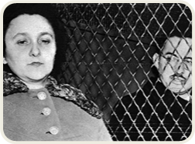 | Alger Hiss and the Rosenbergs

6. In 1948, Whittaker Chambers accused
7. Congressman, , kept the issue alive. Hiss was later and .
8. A few months later, Julius and Ethel Rosenberg were
9. The Rosenbergs claimed that they were victims of . They were later .
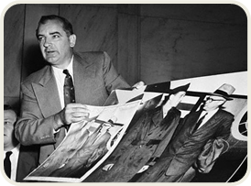 | McCarthyism

10. Who was Joseph McCarthy?
11. How did he achieve fame in 1950?
12. How and when did McCarthy begin to lose support?

