Name:

Date:

School:

Facilitator:

7.02 Isolation Cartoon

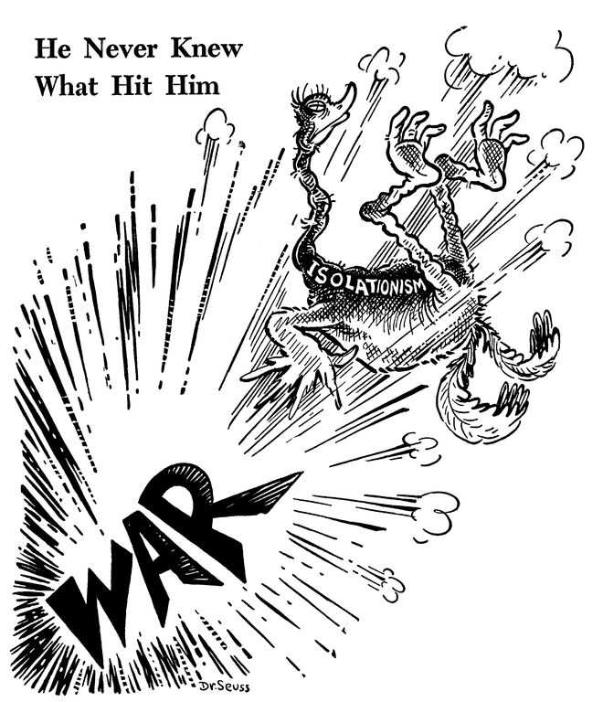

*He never knew what hit him*, published by PM Magazine on December 8, 1941, Dr. Seuss Collection, MSS 230. Special Collections & Archives, UC San Diego Library. [**Dr. Seuss Collection, MSS 230**](http://libraries.ucsd.edu/speccoll/testing/html/mss0230a.html)

1. Define **isolationism**:
2. Why is **isolationism** represented as a bird in the cartoon?
3. What event(s) does the phrase “He never knew what hit him” refer to?
4. Write a paragraph explaining the overall idea and meaning of the cartoon. What does this cartoon tell us about the position that the U.S. took during the first years of World War II and what event changed that position?