Name:

Date:

School:

Facilitator:

5.01 Red Scare and Immigration Questions

**Communism v. Democracy**

1. A popular American history textbook argued that communist form of government in the Soviet Union meant the following:

* The government owned all land and property
* A single political party controlled the government
* Individuals had no rights the government was bound to respect
* The Soviet government promised to spread communism throughout the globe

Many Americans living in the 1920s believed these ideas. Why do you think Americans were afraid of the Soviet communist government?

**Labor Strikes**

2. The post-war period witnessed several labor strikes throughout the United States. Why did middle class Americans and wealthy industrialists have a different perspective on labor issues and strikes than the laborers?

The two political cartoons pictured on the following page were created in the wake of World War I. They each portray similar themes and reflect the turmoil that existed in the nation during the period. Choose one of the cartoons and answer the following questions:

3. Who was the author?

4. When was it published?

5. What is the author’s perspective of the post-World War I world? How was it portrayed in the cartoon?

6. Does this cartoon support or challenge what you already know about the labor strikes? Explain.

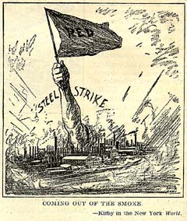

**Image 1** Kirby, “Coming out of the Smoke” (October 10, 1919)

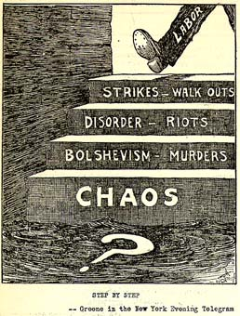

**Image 2** Greene, “Step by Step” (November 1, 1919)

**Constitutional Rights**

Read Section 3 of the Sedition Act below and answer the questions that follow.

***Whoever, when the United Sates is at war, shall willfully make or convey false reports or false statements with intent to interfere with the operation or success of the military or naval forces of the United States or to promote the success of its enemies…or incite insubordination, disloyalty, mutiny, or refusal of duty, in the military or naval forces of the United States, or shall willfully obstruct…the recruiting or enlistment service of the United States, or…shall willfully utter, print, write, or publish any disloyal, profane, scurrilous, or abusive language about the form of government of the United States, or the Constitution of the United States, or the military or naval forces of the United States…or shall willfully display the flag of any foreign enemy, or shall willfully…urge, incite, or advocate any curtailment of production…or advocate, teach, defend, or suggest the doing of any of the acts or things in this section enumerated and whoever shall by word or act support or favor the cause of any country with which the United States is at war or by word or act oppose the cause of the United States therein, shall be punished by a fine of not more than $10,000 or imprisonment for not more than twenty years, or both.***

7. In your own words, list three particular activities made illegal by Section 3 of the Sedition Act.

8. In general terms, what do all the crimes listed within the Sedition Act have in common?

9. Is it possible to engage in any of the activities listed above and not be considered a traitor to the United States? Explain using at least 2 sentences.

Read the 1st Amendment to the Constitution below.

***Congress shall make no law respecting an establishment of religion, or prohibiting the free exercise thereof; or abridging the freedom of speech, or of the press; or the right of the people peaceably to assemble, and to petition the government for a redress of grievances.***

10. Write a 3 sentence summary explaining how the Sedition Act and First Amendment were in conflict with one another.

11. Even though there were certainly Americans during the 1920s that knew of this conflict, most did not speak up. Why do you think they refused to speak up? Explain. Would you?

12. In your opinion, when, if ever, does the government have the right to suppress free speech and nullify (declare invalid) the First Amendment? Explain using at least 3 sentences.

**Immigration**

The cartoon pictured below was published during the Red Scare of 1919-1920. Examine the cartoon and complete the questions below.

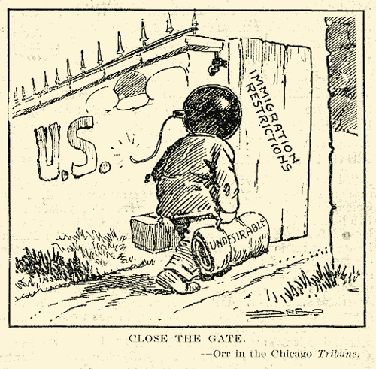

13. Who created this cartoon? Where was it published?

14. What opinion is the author trying to show about immigration?

15. Does this cartoon support or challenge what you knew about the immigration in the 1920s? Explain using at least 2 sentences.