Name:

Date:

School:

Facilitator:

4.03 Political Cartoon Analysis

Analyze the cartoon below by describing what the snake, the child with a stick, and the other two children represent. Answer each question using at least one complete sentence.

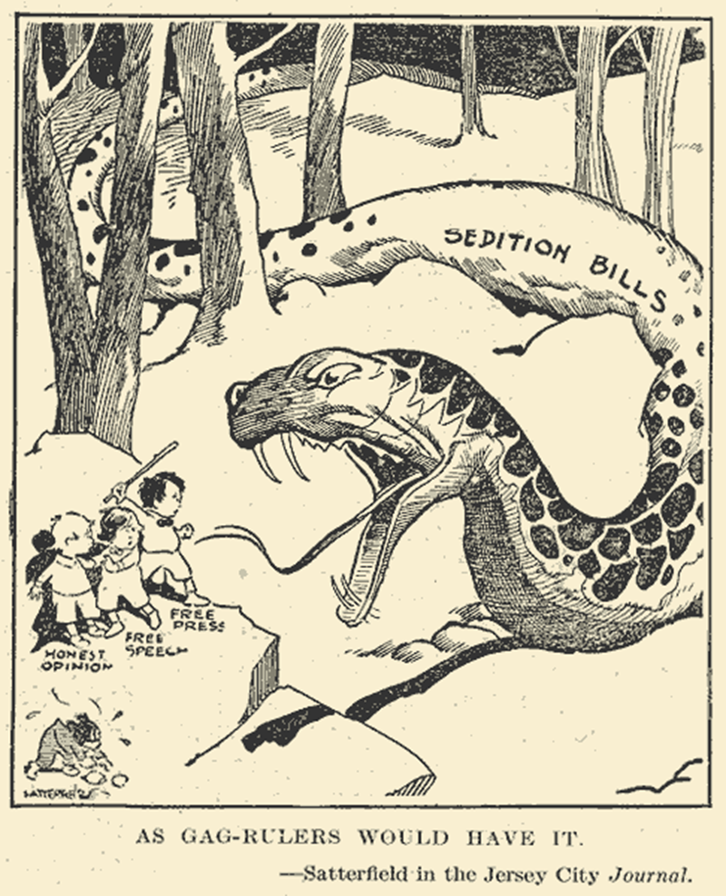

1. What does the snake represent and why?
2. What does the child with the stick represent and why?
3. What do the other two children represent and why?
4. Think about the overall meaning of the cartoon. In times of war or national emergency, how do you balance the need for security with the rights of individuals? (Helpful Hint: think about the homeland security measures that have been in place since the events of 9/11/2001)