**1.03 Primary Sources**

**Rockefeller**

**Source 1**

“Next!”

This political cartoon by Udo J. Keppler appeared in the September 7, 1904, issue of

*Puck*. *Puck* was one of America’s first humor magazines.

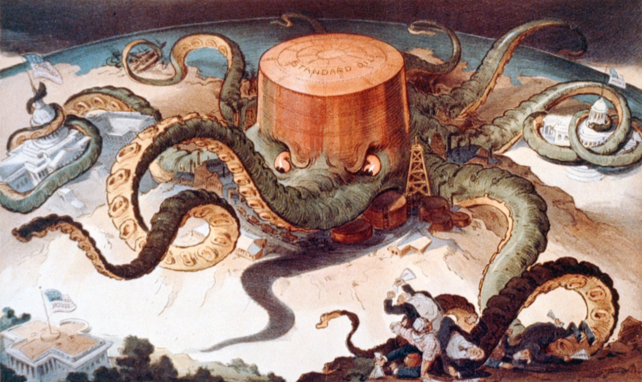

**Source 2**

**A quote from John D. Rockefeller in an interview with William Hoster, quoted in God's Gold (1932) by**

**John T. Flynn**

“I believe the power to make money is a gift of God … to be developed and used to the best of our ability for the good of mankind. Having been endowed with the gift I possess, I believe it is my duty to make money and still more money and to use the money I make for the good of my fellow man according to the dictates of my conscience.”

**Source 3**

**The History of the Standard Oil Company written by Ida Tarbell in 1904**

In the fall of 1871, Rockefeller and some other oil refiners developed a remarkable scheme, the gist of which was to bring together secretly a large enough body of refiners and shippers to persuade all the railroads handling oil to give to the company formed special rebates on its oil, and drawbacks on that of other people. If they could get such rates it was evident that those outside of their combination could not compete with them long and that they would become eventually the only refiners. They could then limit their output to actual demand, and so keep up prices. This done, they could easily persuade the railroads to transport no crude for exportation, so that the foreigners would be forced to buy American refined. They believed that the price of oil thus exported could easily be advanced fifty per cent. The control of the refining interests would also enable them to fix their own price on crude. As they would be the only buyers and sellers, the speculative character of the business would be done away with.

**Carnegie**

**Source 1**

“Forty-Millionaire Carnegie in his Great Double Role”

This cartoon was published in 1892 in Pittsburgh’s *The Saturday Globe*

[**http://herb.ashp.cuny.edu/items/show/636**](http://herb.ashp.cuny.edu/items/show/636)

**Source 2**

**Andrew Carnegie’s Essay, “Wealth,” published in the *North American Review* in 1889**

“This, then, is held to be the duty of the man of wealth: First, to set an example of modest, unostentatious living, shunning display or extravagance; to provide moderately for the legitimate wants of those dependent upon him; and, after doing so, to consider all surplus revenues which come to him simply as trust funds, which he is called upon to administer, and strictly bound as a matter of duty to administer in the manner which, in his judgment, is best calculated to produce the most beneficial results for the community /the man of wealth thus becoming the mere trustee and agent for his poorer brethren, bringing to their service his superior wisdom, experience and ability to administer, doing for them better than they would or could do for themselves.”

**Source 3**

**Account of Carnegie’s Management during the Homestead Strike**

"While the slaughter was going on," joined the Cleveland Plain Dealer, "Partner Carnegie was at his castle in Scotland enjoying his more than princely income and posing as a benefactor of the working class and a general friend to humanity." Senator Voorhees of Indiana added, "Men like Carnegie and his class are so bloated, arrogant, and plethoric of wealth...that they think they can employ a private army themselves to ride over American citizens."