**Lesson 1.03 Growth of Big Business**

**Big Business (Tab 1)**

**Growth of Big Business**

During the Gilded Age the United States experienced a second industrial revolution (the first occurred in the early 1800s). The New Industrial Revolution (also referred as the **Second Industrial Revolution**) witnessed the large scale conversion from simple hand tools to large industrial machines. Americans in large number found jobs outside of their home with regular hours and disposable income. Americans fled family farms to work in big factories in the city, and more goods were bought rather than produced at home. Cities such as Philadelphia, New York, and Chicago exploded in size with the expansion of industry. In the process, big businesses were created that helped revolutionize the way America did business. This industrial boom enabled the United States to surpass rival European nations as the largest industrial power in the world.

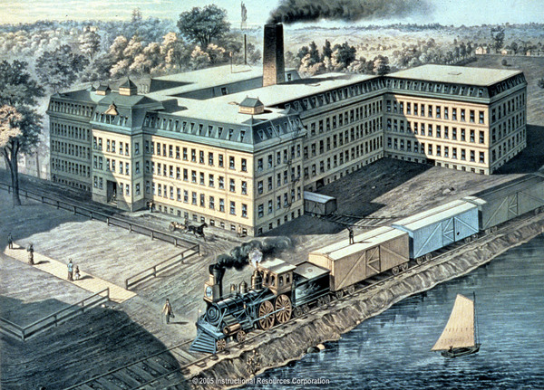

A shoe factory in Plymouth, Massachusetts. IRC, 2005. Image. Discovery Education. Web. 23 February 2014. <http://www.discoveryeducation.com/>.

Open [1.03 Note Sheet](http://accessdl.state.al.us/AventaCourses/access_courses/ushistory11_ua_v14/01_unit/01-05/01-05_notes.docx) and fill it in while reading the information provided at the links below. Save your completed notes. They will help you with the Tasks and serve as a study tool for the Unit Test.

[The Gilded Age](http://www.ushistory.org/us/36.asp)

[Binding the Nation by Rail](http://www.ushistory.org/us/36a.asp)

[Overview of the Gilded Age](http://www.digitalhistory.uh.edu/era.cfm?eraid=9)

[The Second Industrial Revolution, 1870-1914](http://www.ushistoryscene.com/uncategorized/secondindustrialrevolution/)

Watch [*An Introduction to the American Industrial Revolution*](http://player.discoveryeducation.com/index.cfm?guidAssetId=22A40A09-2A28-43D2-8444-D5320B80E0B3) (1:12) for a brief introduction to the American Industrial Revolution.

Click here to view the instructions for logging in to Discovery Education Streaming videos.

**Captain v. Robber (Tab 2)**

**Industry Leaders**

You have most likely heard of Rockefeller Center, Carnegie Hall, or J.P. Morgan Chase Bank. The men behind these names were industrial leaders from the Gilded Age and are often viewed with conflicting perspectives. Many consider these leaders [**Captains of Industry**](http://accessdl.state.al.us/AventaCourses/access_courses/ushistory11_ua_v14/01_unit/01-05/01-05_learn.htm) for their achievements in creating large industrial empires and for their contributions made to society. Others, however, viewed them as [**Robber Barons**](http://accessdl.state.al.us/AventaCourses/access_courses/ushistory11_ua_v14/01_unit/01-05/01-05_learn.htm) for amassing great wealth at the expense of others and, at times, without regard to the law.

**Rollover the image to learn more about each Captain of Industry/Robber Baron. (Below)**

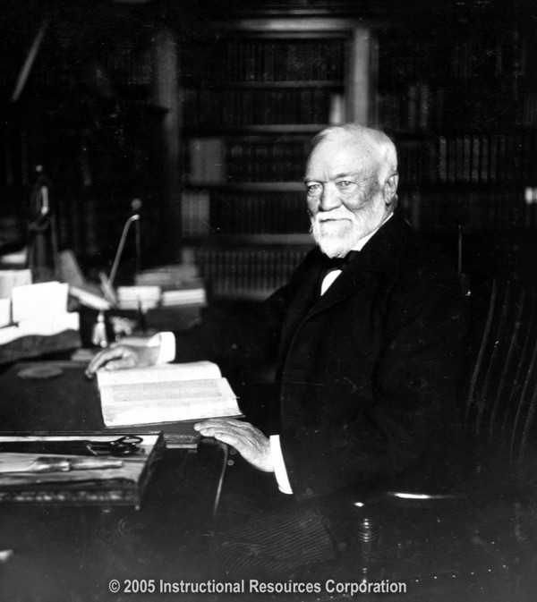 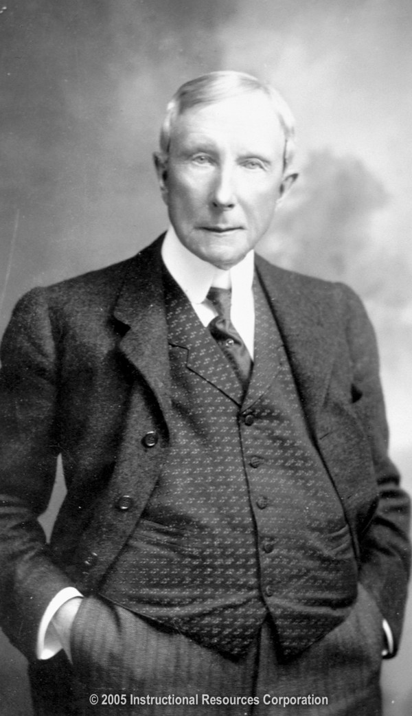 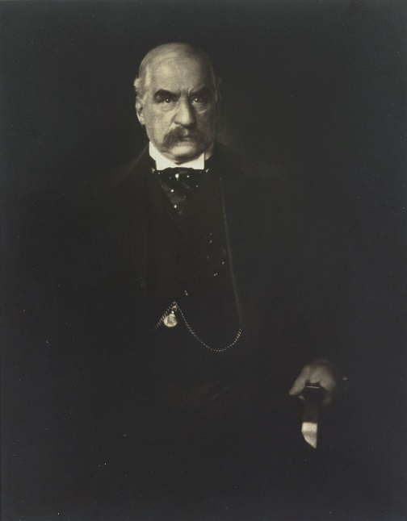  
Andrew Carnegie                            John D. Rockefeller J.P. Morgan

The growth of big business in the late 1800s created enormous amounts of wealth in America. Most of this wealth belonged to a small minority of Americans. Many of these wealthy individuals made their fortunes by amassing large monopolies or trusts in their industry. Largely unchallenged by government rules and regulations, these empires became quite powerful controlling nearly, if not all, of the competition in their industry. The "captains" critics claimed they "robbed" the nation of wealth by not distributing it more equally among their workers. Despite these claims, many of the "Captains of Industry" donated large portions of their wealth to benefit society in ways that affect many Americans even today.

 Learn more about three of the leading industrialists from the era in the readings listed below. Continue working on 1.03 Note Sheet as you review the material. Remember to save the notes to your locker. They will help you with the Tasks and serve as a study guide for the Unit Test.

[Andrew Carnegie](http://www.ushistory.org/us/36c.asp)

[John Rockefeller](http://www.ushistory.org/us/36b.asp)

[J.P. Morgan](http://www.ushistory.org/us/36d.asp)

Photograph Citations:

*Andrew Carnegie (1835-1919).* IRC, 2005.Image. *Discovery Education*. Web. 23 February 2014. <http://www.discoveryeducation.com/>.

*John Davison Rockefeller (1839-1937).* IRC, 2005.Image. *Discovery Education*. Web. 23 February 2014. <http://www.discoveryeducation.com/>.

**Rollover for images:**

**Andrew Carnegie was an immigrant from Scotland who rose from “rags to riches” and became captain of the steel industry by cutting cost and increasing production.**

**John D. Rockefeller was America’s first billionaire who rose from humble beginnings to found Standard Oil. By the late 1870s, he controlled about 90% of the nation’s oil-refining capacity.**

**J. Pierpont Morgan’s family had great wealth; however, he was a great financier and banker in his own rite. During the Gilded Age, he dominated corporate finance and industrial consolidation. He arranged the merger that created General Electric and United States Steel Corporation.**

**Government Regulations (Tab 3) I would turn the original information in the third learning tab into a second tab in the Try it section, “Bonus Info”, which becomes a regular Try it tab in the future units I created. Replace the original information with the following.**

While these Captains of Industry helped fuel the American Industrial Revolution, they did so by reducing competition, often adversely affecting the consumer. Thus, in 1887, the government passed the **Interstate Commerce Act** (regulated railroads and other interstate businesses), followed three years later by the **Sherman Anti-Trust Act** (prohibited combinations in restraint of trade or in other words, designed to break up trusts). Though both acts were designed to protect consumer interests, they were both fairly limited in scope and not stridently enforced. Their passage, however, was significant because it established the precedent for future regulatory actions by the government.

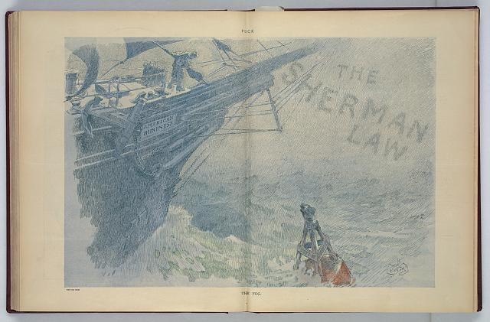

The Fog: The cartoon shows a ship labeled "American Business" sailing into a fog labeled "The Sherman Law" and passing a bell buoy labeled "Dept. of Justice".

Crawford, Will, 1869-1944, artist. *The Fog.*  N.Y. : Published by Keppler & Schwarzmann, Puck Building, 1911 November 22. Image. Retrieved from the Library of Congress, <http://www.loc.gov/pictures/item/2011649081/>

As industrialists became increasingly wealthy during the Gilded Age, controversy surrounding their new found wealth grew as well. The root of the controversy stemmed from the large income gap that existed between the industrialists and their workers. Many industrialists defended this gap by arguing that their wealth was well-deserved and necessary. To justify these beliefs, some industrialists promoted the **Social Darwinism** ideas of "survival of the fittest" where the strong and intelligent naturally surpass the weak. Some industrialists, like Carnegie, agreed that wealth was deserved, but that with it came a moral responsibility to act righteously. Though the workers themselves felt they deserved part of the fortune for enduring tough working conditions, the government by and large was unresponsive to their needs. Despite the passage of the Interstate Commerce Act and Sherman Anti-Trust Act, big business by and large enjoyed an existence free of government regulation.

**I would take the original information from the third learning tab and move it into a second tab in the Try it section, “Bonus Info”, which becomes a regular Try it tab in the future units I created.**

**Bonus Info (Tab 2 in the Try it section)**

Explore more information about the millionaires of the Gilded Age by reading the information at the links below:

**Tour of Homes**



Many of the wealthy industrialists from the Gilded Age spent their fortunes on grand homes across the country. Take a tour of one such home with the Berwind family in Newport, Rhode Island. Can you believe it was just their summer home?

[Tour The Elms](http://www.pbs.org/wgbh/amex/carnegie/sfeature/tour.html) http://www.pbs.org/wgbh/amex/carnegie/sfeature/tour.html

[Gallery: Millionaire’s Row](http://www.pbs.org/wgbh/amex/carnegie/gallery/index.html) <http://www.pbs.org/wgbh/amex/carnegie/gallery/index.html>

[Rags to Riches Timeline](http://www.pbs.org/wgbh/amex/carnegie/timeline/f_timeline.html) <http://www.pbs.org/wgbh/amex/carnegie/timeline/f_timeline.html>

**Lesson 1.05 Growth of Big Business**

**Big Business (Tab 1)**



**Growth of Big Business**

The New Industrial Revolution (also referred as the Second Industrial Revolution) witnessed the large scale conversion from simple hand tools to large industrial machines. Americans in large number found jobs outside of their home with regular hours and disposable income. Cities such as Philadelphia, New York, and Chicago exploded in size with the expansion of industry.

Open [1.05 Note Sheet](http://accessdl.state.al.us/AventaCourses/access_courses/ushistory11_ua_v14/01_unit/01-05/01-05_notes.docx) and fill it in while reading the information provided at the links below. Save your completed notes. They will help you with the Tasks and serve as a study tool for the Unit Test.

[The Gilded Age](http://www.ushistory.org/us/36.asp)

[Binding the Nation by Rail](http://www.ushistory.org/us/36a.asp)

[Overview of the Gilded Age](http://www.digitalhistory.uh.edu/era.cfm?eraid=9)

[The Second Industrial Revolution, 1870-1914](http://www.ushistoryscene.com/uncategorized/secondindustrialrevolution/)

Painting Citation:

A shoe factory in Plymouth, Massasschusetts. IRC, 2005. Image. Discovery Education. Web. 23 February 2014. <http://www.discoveryeducation.com/>.

**Captain v. Robber (Tab 2)**

   
Andrew Carnegie                            John Rockefeller

**Industry Leaders**

The industrial leaders from the Gilded Age are often viewed with conflicting perspectives. Many consider the leaders [**Captains of Industry**](http://accessdl.state.al.us/AventaCourses/access_courses/ushistory11_ua_v14/01_unit/01-05/01-05_learn.htm) for their achievements and contributions they made to society. Others, however, view them as [**Robber Barons**](http://accessdl.state.al.us/AventaCourses/access_courses/ushistory11_ua_v14/01_unit/01-05/01-05_learn.htm) for amassing great wealth at the expense of others and, at times, without regard to the law.

 Learn more about three of the leading industrialists from the era in the readings listed below. Continue working on [1.05 Note Sheet](http://accessdl.state.al.us/AventaCourses/access_courses/ushistory11_ua_v14/01_unit/01-05/01-05_notes.docx)as you review the material. Remember to save the notes to your locker. They will help you with the Tasks and serve as a study guide for the Unit Test.

[Andrew Carnegie](http://www.ushistory.org/us/36c.asp)

[John Rockefeller](http://www.ushistory.org/us/36b.asp)

[J.P. Morgan](http://www.ushistory.org/us/36d.asp)

Photograph Citations:

*Andrew Carnegie (1835-1919).* IRC, 2005.Image. *Discovery Education*. Web. 23 February 2014. <http://www.discoveryeducation.com/>.

*John Davison Rockefeller (1839-1937).* IRC, 2005.Image. *Discovery Education*. Web. 23 February 2014. <http://www.discoveryeducation.com/>.

**Tour of Homes (Tab 3)**



Many of the wealthy industrialists from the Gilded Age spent their fortunes on grand homes across the country. Take a tour of one such home with the Berwind family in Newport, Rhode Island. Can you believe it was just their summer home?

[Tour The Elms](http://www.pbs.org/wgbh/amex/carnegie/sfeature/tour.html)