**5.02 Project Work Associate Editor**

Name:

Date:

School:

Facilitator:

1. What is the title of your group’s magazine?
2. What comments did you contribute toward the group’s discussion on layout design?

As the Associate Editor, your role for the magazine is to create the layouts for the interior of your group’s magazine. Communicate with your Editor in Chief through the group discussion about which publication format your group will use for the final magazine product (Word, PowerPoint, Adobe InDesign, etc.) and then use the space below to create a rough draft of the magazine page layouts.

Here is a sample layout design:

Page 1:

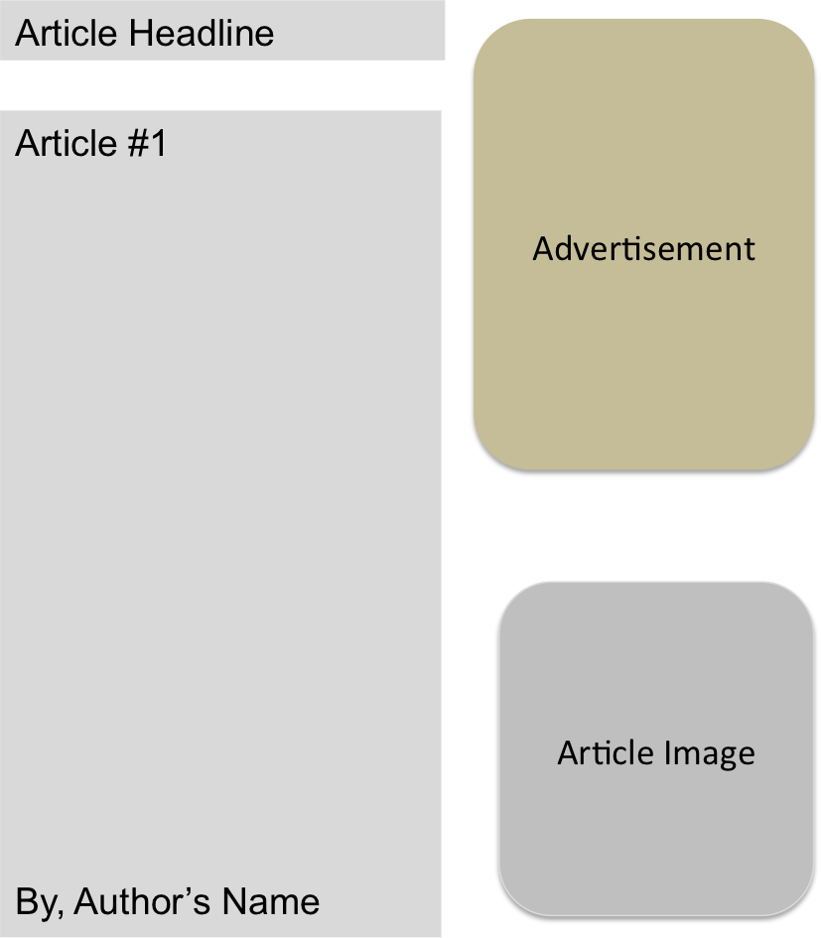

Keep in mind that your group’s magazine will include the following items:

1. One 3-paragraph article with an image for each member of your group.
2. One advertisement for each member of your group.
3. One 3-paragraph editorial for each member of your group.