Name:
Date:
School:
Facilitator:

5.11 Visualizing the Trail of Tears
Total Points: 25
Using the map below and your knowledge of the lesson, please answer each question in complete sentences.
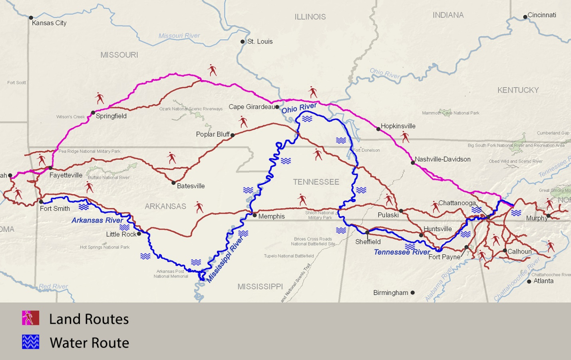
- One of the largest groups of Cherokee left Tennessee in the late fall of 1838 using the far-northern route and arrived in Indian Territory by March of 1839. This was a land route. Based on the evidence from the map, list three challenges you think they may have faced while making a land journey on foot.
Challenge 1:
Challenge 2:
Challenge 3:

- Find the water route on the map. What rivers does it follow? What advantages do you think the water route may have had over the land route? How might it have been more difficult than traveling over land?
Write your response below:

- If you were part of a Cherokee group with the choice of traveling by the land or water route, which would you want to travel? Why?
Write your response below:

In the 1830s, the Cherokee were divided on the issue of adopting aspects of white, European-American culture or trying to maintain an indigenous culture and identity. Read and review the excerpts below and answer the questions.

Chief Womankiller Passage. 1829.
On motion of Choonnagkee of Chickamauga District, an old law, making death the penalty for selling any lands in treaty, without the authority of the nation, was committed to writing. The bill was adopted. Womankiller, of Hickory Log District, who is probably more than eighty years of age, rose and spoke substantially as follows in reference to the bill:

My Children,

Permit me to call you so as I am an old man, and has lived a long time, watching the well being of this Nation. I love your lives, and wish our people to increase on the land of our fathers. The bill before you is to punish wicked men, who may arise to cede away our country contrary to the consent of the Council. It is a good law -- it will not kill the innocent but the guilty. I feel the importance of the subject, and am glad the law has been suggested.

My companions, men of renown, in Council, who now sleep in the dust, spoke the same language, and I now stand on the verge of the grave to bear witness to their love of country. My sun of existence is fast approaching to its sitting, and my aged bones will soon be laid under ground, and I wish them laid in the bosom of this earth we have received from our fathers who had it from the Great Being above. When I shall sleep in forgetfulness, I hope my bones will not be deserted by you.

I do not speak this in fear of any of you, as the evidence of your attachment to the country is proved by the bill now before your consideration, I am indeed told, that the Government of the U. States will spoil their treaties with us and sink our National Council under their fee. It may be so, but it shall not be without our consent, or by the misconduct of our people. We hold them by the golden chain of friendship; made when our friendship was worth a price, and if they act the tyrant and kill us for our lands, we shall, in a state of unoffending innocence, sleep with the thousands of our departed people.

My feeble limbs will not allow me to stand longer. I can say no more, but, before I sit, allow me to tell you that I am in favor of the bill.

Source: The Cherokee Nation at Cherokee.Org, About the Nation, Facts, Council Meetings from 1829. www.cherokee.org/About-The-Nation/History/Facts/Council-Meetings-from-1829.

- What arguments does Chief Womankiller make in his presentation to the Cherokee Nation and its council? What are his concerns?
Write your response below:

Chief John Ross Letter Protesting the Treaty of New Echota

Letter from Chief John Ross, “To the Senate and House of Representatives” [Red Clay Council Ground, Cherokee Nation, September 28, 1836]

It is well known that for a number of years past we have been harassed by a series of vexations, which it is deemed unnecessary to recite in detail, but the evidence of which our delegation will be prepared to furnish. With a view to bringing our troubles to a close, a delegation was appointed on the 23rd of October, 1835, by the General Council of the nation, clothed with full powers to enter into arrangements with the Government of the United States, for the final adjustment of all our existing difficulties.
The delegation failing to effect an arrangement with the United States commissioner, then in the nation, proceeded, agreeably to their instructions in that case, to Washington City, for the purpose of negotiating a treaty with the authorities of the United States.

After the departure of the Delegation, a contract was made by the Rev. John F. Schermerhorn, and certain individual Cherokee, purporting to be a "treaty, concluded at New Echota, in the State of Georgia, on the 29th day of December, 1835, by General William Carroll and John F. Schermerhorn, commissioners on the part of the United States, and the chiefs, headmen, and people of the Cherokee tribes of Indians."

A spurious Delegation, in violation of a special injunction of the general council of the nation, proceeded to Washington City with this pretended treaty, and by false and fraudulent representations supplanted in the favor of the Government the legal and accredited Delegation of the Cherokee people, and obtained for this instrument, after making important alterations in its provisions, the recognition of the United States Government.

And now it is presented to us as a treaty, ratified by the Senate, and approved by the President [Andrew Jackson], and our acquiescence in its requirements demanded, under the sanction of the displeasure of the United States, and the threat of summary compulsion, in case of refusal. It comes to us, not through our legitimate authorities, the known and usual medium of communication between the Government of the United States and our nation, but through the agency of a complication of powers, civil and military.

By the stipulations of this instrument, we are despoiled of our private possessions, the indefeasible property of individuals. We are stripped of every attribute of freedom and eligibility for legal self-defence. Our property may be plundered before our eyes; violence may be committed on our persons; even our lives may be taken away, and there is none to regard our complaints. We are denationalized; we are disfranchised. We are deprived of membership in the human family! We have neither land nor home, nor resting place that can be called our own. And this is effected by the provisions of a compact which assumes the venerated, the sacred appellation of treaty.

We are overwhelmed! Our hearts are sickened, our utterance is paralyzed (sic), when we reflect on the condition in which we are placed, by the audacious practices of unprincipled men, who have managed their stratagems with so much dexterity as to impose on the Government of the United States, in the face of our earnest, solemn, and reiterated protestations.

The instrument in question is not the act of our Nation; we are not parties to its covenants; it has not received the sanction of our people. The makers of it sustain no office nor appointment in our Nation, under the designation of Chiefs, Head men, or any other title, by which they hold, or could acquire, authority to assume the reins of Government, and to make bargain and sale of our rights, our possessions, and our common country.
And we are constrained solemnly to declare, that we cannot but contemplate the enforcement of the stipulations of this instrument on us, against our consent, as an act of injustice and oppression, which, we are well persuaded, can never knowingly be countenanced by the Government and people of the United States; nor can we believe it to be the design of these honorable and highminded individuals, who stand at the head of the Govt., to bind a whole Nation, by the acts of a few unauthorized individuals.
And, therefore, we, the parties to be affected by the result, appeal with confidence to the justice, the magnanimity, the compassion, of your honorable bodies, against the enforcement, on us, of the provisions of a compact, in the formation of which we have had no agency.

Source: The Papers of Chief John Ross, vol 1, 1807-1839, Norman OK. Gary E. Moulton, ed. University of Oklahoma Press, 1985. http://www.pbs.org/wgbh/aia/part4/4h3083t.html

- What arguments does Chief John Ross make? How is his writing different from Chief Womankiller’s? Why do you think they might be different?
Write your response below:

