Name:
Date:
School:
Facilitator:

4.07 The Monroe Doctrine
Total Points: 48

Part 1: The Monroe Administration
Answer the following in complete sentences.
- What happened in the United States after the War of 1812? (Hint: Make you mention the Era of Good Feelings and the Panic of 1819 and describe them.)
Write your response below:

- What was the Monroe Doctrine? What were its key points?
Write your response below:

- How did the Monroe Doctrine come about?
Write your response below:

Part 2: Political Cartoon
The political cartoon titled “His Foresight” below is about the Monroe Doctrine. Analyze the cartoon. Choose three characters, objects, or words to describe and then explain the overall meaning of the cartoon. A larger version of the cartoon is linked on the Task page.
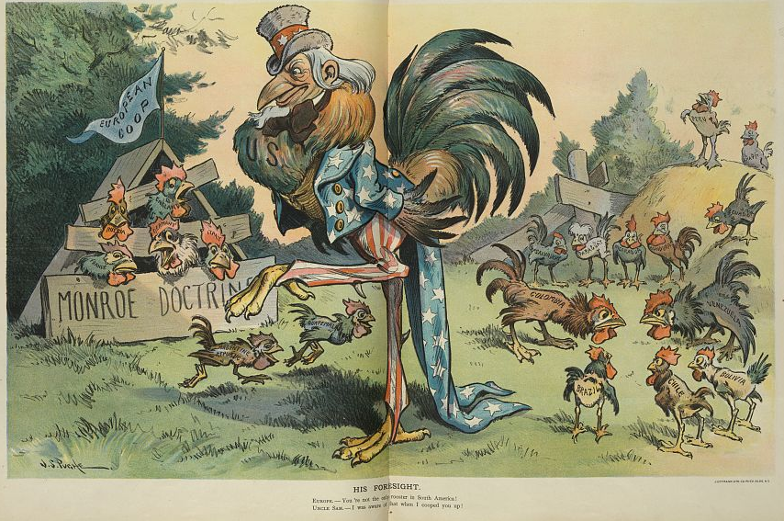
The caption reads:
His Foresight.
Europe: You're not the only rooster in South America!
Uncle Sam: I was aware of that when I cooped you up!

- Choose three characters, objects, or words from the cartoon above. Write at least one complete sentence about each and describe its significance to the overall meaning of the cartoon.
  - Character/Object #1:
  - Character/Object #2:
  - Character/Object #3:
- Write at least one sentence to explain the overall idea, meaning, or significance of the cartoon.

Part 3: US Foreign Relations
Think about all you have learned about the US’s foreign relations with Britain and France throughout this unit. How did the United States develop lasting independence from Europe, despite challenges from Great Britain and France? Respond in at least one complete paragraph.
Write your response below:

