Name:

Date:

School:

Facilitator:

* 1. Brain Diagram

Complete the diagram of the brain by labeling the part of the brain.

Give two functions for each labeled part of the brain.

Explain two consequences of damage to each labeled part of the brain.

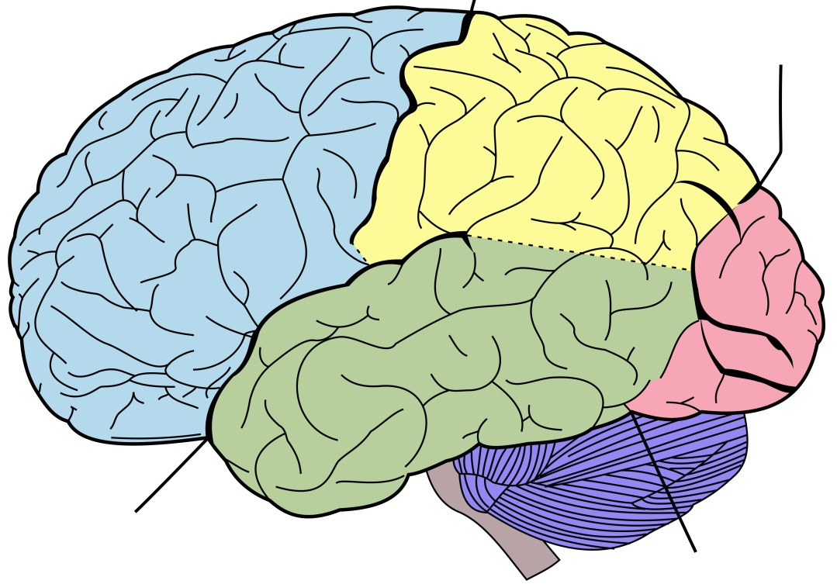

**E**

**F**

**D**

**C**

**B**

**A**

Label the six parts of the brain:



Brain Part Give Two Functions

Frontal Lobe

Parietal Lobe

Temporal Lobe

Occipital Lobe

Cerebellum

Brain stem

Explain two consequences of damage to each labeled part of the brain.

1.

2.

3.

4.

5.

6.