Name:

Date:

School:

Facilitator:

4.05 Explore

# Trig Hand

This is a really good mnemonic for remembering the sine and cosine for the five reference angles.

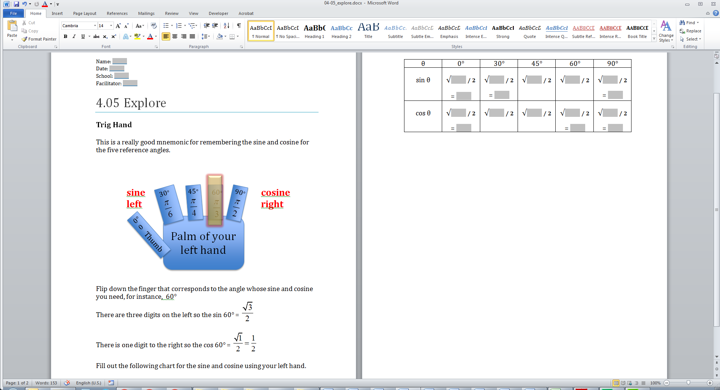

Flip down the finger that corresponds to the angle whose sine and cosine you need, for instance, 60°

There are three digits on the left so the $\sin{60°=\frac{\sqrt{3}}{2}}$

There is one digit to the right so the $\cos{60°=\frac{\sqrt{1}}{2}=\frac{1}{2}}$

Fill out the following chart for the sine and cosine using your left hand.

|  |  |  |  |  |  |
| --- | --- | --- | --- | --- | --- |
| θ | 0° | 30° | 45° | 60° | 90° |
| sin θ | √**/ 2**  = | √**/ 2**  = | √**/ 2** | √**/ 2** | √**/ 2**  = |
| cos θ | √**/ 2**  = | √**/ 2** | √**/ 2** | √**/ 2**  = | √**/ 2**  = |