Name:
Date:
School:
Facilitator:

4.08 Other Trig Function Graphs
1. Find the following for 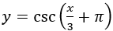, then sketch the graph.

a. Phase Shift

b. Period

c. Two consecutive vertical asymptotes

Sketch graph here:

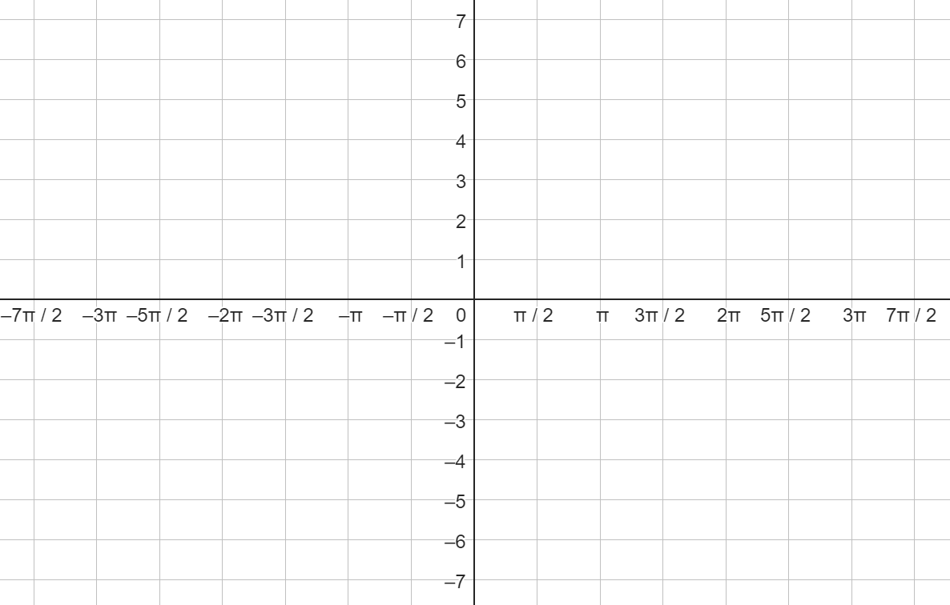

2. Find the following for 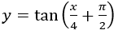, then sketch the graph.

a. Phase Shift

b. Period

c. Two consecutive vertical asymptotes

Sketch graph here:

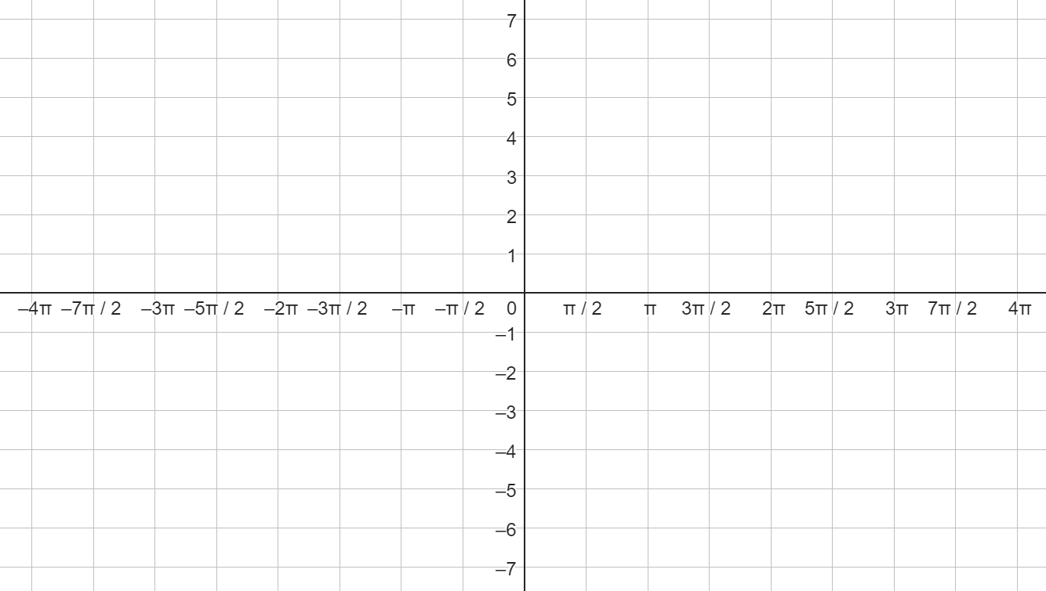

3. Find the following for $y = sec(x – π)$, then sketch the graph.

a. Phase Shift

b. Period

c. Two consecutive vertical asymptotes

Sketch graph here:

4. Find the following for 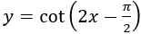, then sketch the graph.

a. Phase Shift

b. Period

c. Two consecutive vertical asymptotes

Insert graph here:

