Name:
Date:
School:
Facilitator:

Rational Function Graphs
Note: You must submit a sketch of the function. Use the line tools in Word to help sketch your function if you do not have access to a tablet. You can also drag and drop the elements supplied.
1. Find the following and sketch the graph of the rational function 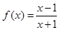
a) Domain: b) Range:
c) Y-intercept: d) X-intercept:
e) Vertical Asymptotes: f) Horizontal Asymptote:
g) Slant Asymptote: h) Increasing Intervals:
i) Decreasing Intervals: j) Maximum Points:
k) Minimum Points: l) Symmetry:

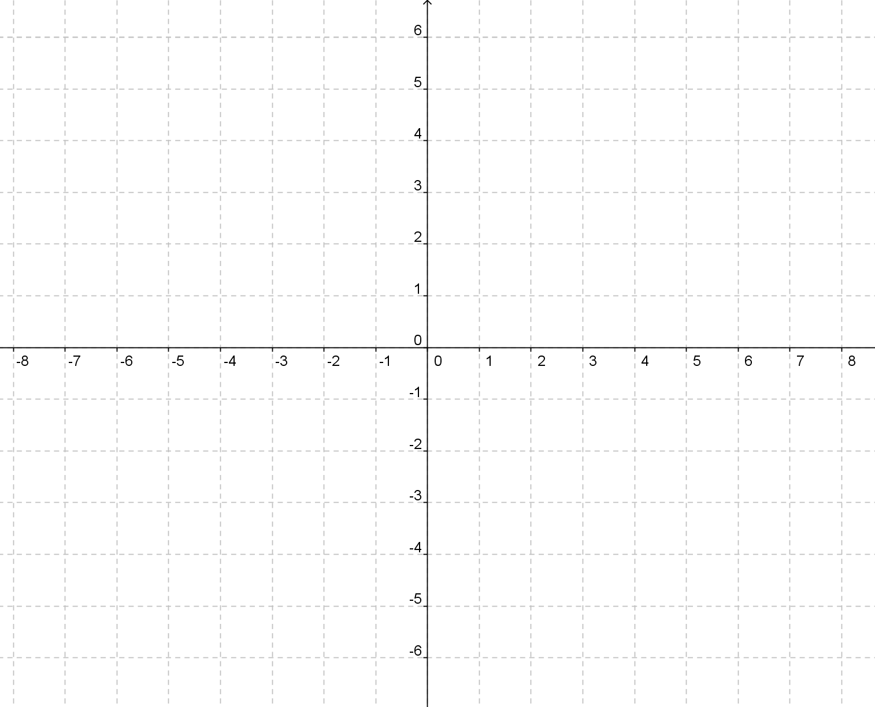
vertical asymptote
y-intercept
x-intercept

horizontal asymptotes

2. Find the following and sketch the graph of the rational function 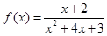

a) Domain: b) Range:
c) Y-intercept: d) X-intercept:
e) Vertical Asymptotes: f) Horizontal Asymptote:
g) Slant Asymptote: h) Increasing Intervals:
i) Decreasing Intervals: j) Maximum Points:
k) Minimum Points: l) Symmetry:

x-intercept
y-intercept
vertical asymptote
horizontal asymptotes

