2.09 Graphs of Rational Functions Additional Practice Key
Solve the problems below. Then, compare your answers and work to the 2.09 Graphs of Rational Functions Additional Practice Key.
1. Sketch the graph of the rational function
$f(x)=\frac{x^{2}-9}{x-2}$
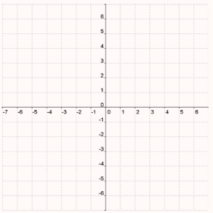
Find the domain: all real numbers except x = 2
Find the range: all real numbers or $(-∞,∞)$
Find and plot the y-intercept: (0, $\frac{9}{2}$ ) ; found by solving the function for x = 0
Find and plot the x-intercepts: (3, 0) and (−3, 0); found by letting f(x) = 0
Find and draw the vertical asymptote: x = 2; found by setting the denominator equal to 0
Find the discontinuities: The vertical asymptote is the only discontinuity.
Find and draw the horizontal asymptote: There is no horizontal asymptote, because the degree of the numerator > degree of the denominator.
Find and draw the slant asymptote: y = x + 2; the slant asymptote is the quotient when you divide the numerator by the denominator.
Find the values of y for these values of x to the left of the vertical asymptote. Round the y-values to one decimal place. Plot the (x, y) coordinates:
x = −4; y = −1.2
x = −5; y = −2.3
x = −6; y = −3.4
Find the values of y for these values of x to the right of the vertical asymptote. Round the y-values to one decimal place. Plot the (x, y) coordinates:
x = 4; y = 3.5
x = 5; y = 5.3
x = 6; y = 6.8
Use the points you have plotted to sketch the graph. Find the intervals of increasing and decreasing:
Increasing: $(-∞, 2)∪(2, ∞)$
Decreasing: never
Find the minimum and maximum points: no minimum or maximum
Test for symmetry: no symmetry ; $f(-x)=\frac{(-x)^{2}-9}{-x-2}=\frac{x^{2}-9}{-(x+2)}$
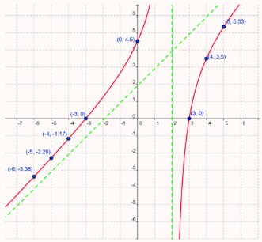

2. Sketch the graph of the rational function
$f(x)=\frac{x^{2}-25}{x^{2}-9}$
Find the domain: all real numbers except x = 3 and x = −3
Find the range: $(-∞, 1)∪( \frac{25}{9}, ∞)$
Find and plot the y-intercept: (0, $\frac{25}{9}$); found by solving the function for x = 0
Find and plot the x-intercepts: (5, 0) and (−5, 0); found by letting f(x) = 0
Find and draw the vertical asymptotes: x = 3 and x = −3; found by setting the denominator equal to 0
Find and draw the horizontal asymptote: y = 1; the degree of the numerator = degree of the denominator, so y equals the leading coefficient of the numerator divided by the leading coefficient of the denominator
Find and draw the slant asymptote: no slant asymptote, because there is a horizontal asymptote
Find the values of y for these values of x to the left of the vertical asymptote. Round the y-values to one decimal place. Plot the (x, y) coordinates:
x = −4; y = −1.3
x = −5; y = 0
x = −6; y = 0.4
Find the values of y for these values of x between the vertical asymptotes. Round the y-values to one decimal place. Plot the (x, y) coordinates:
x = −1; y = 3
x = 0; y = 2.8
x = 1; y = 3
Find the values of y for these values of x to the right of the vertical asymptote. Round the y-values to one decimal place. Plot the (x, y) coordinates:
x = 4; y = −1.3
x = 5; y = 0
x = 6; y = 0.4
Use the points you have plotted to sketch the graph. Find the intervals of increasing and decreasing:
Increasing: $(0, 3)∪(3, ∞)$
Decreasing: $(-∞, -3) ∪ (-3, 0)$
Find the minimum and maximum points: minimum at the y-intercept: (0, $\frac{25}{9}$)
Test for symmetry: $f(-x)=\frac{(-x)^{2}-25}{(-x)^{2}-9}=\frac{x^{2}-25}{x^{2}-9}$ ; This is an even function. It is symmetric to the y-axis.
