2.09 Graphs of Rational Functions

Additional Practice
Solve the problems below. Then, compare your answers and work to the 2.09 Graphs of Rational Functions Additional Practice Key.
1. Sketch the graph of the rational function
$f(x)=\frac{x^{2}-9}{x-2}$
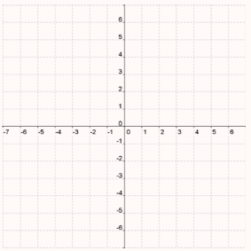
Find the domain:
Find the range:
Find and plot the y-intercept:
Find and plot the x-intercepts:
Find and draw the vertical asymptote:
Find the discontinuities:
Find and draw the horizontal asymptote:
Find and draw the slant asymptote:
Find the values of y for these values of x to the left of the vertical asymptote. Round the y-values to one decimal place. Plot the (x, y) coordinates:
x = −4;
x = −5;
x = −6;
Find the values of y for these values of x to the right of the vertical asymptote. Round the y-values to one decimal place. Plot the (x, y) coordinates:
x = 4;
x = 5;
x = 6;
Use the points you have plotted to sketch the graph. Find the intervals of increasing and decreasing:
Increasing:
Decreasing:
Find the minimum and maximum points:
Test for symmetry:

2. Sketch the graph of the rational function
$f(x)=\frac{x^{2}-25}{x^{2}-9}$
Find the domain:
Find the range:
Find and plot the y-intercept:
Find and plot the x-intercepts:
Find and draw the vertical asymptotes:
Find and draw the horizontal asymptote:
Find and draw the slant asymptote:
Find the values of y for these values of x to the left of the vertical asymptote. Round the y-values to one decimal place. Plot the (x, y) coordinates:
x = −4;
x = −5;
x = −6;
Find the values of y for these values of x between the vertical asymptotes. Round the y-values to one decimal place. Plot the (x, y) coordinates:
x = −1;
x = 0;
x = 1;
Find the values of y for these values of x to the right of the vertical asymptote. Round the y-values to one decimal place. Plot the (x, y) coordinates:
x = 4;
x = 5;
x = 6;
Use the points you have plotted to sketch the graph. Find the intervals of increasing and decreasing:
Increasing:
Decreasing:
Find the minimum and maximum points:
Test for symmetry:

