Name:
Date:
School:
Facilitator:

2.08 Identify Discontinuity
Find the x-values (if any) at which the function is not continuous.
Decide if discontinuities are removable.
Find intervals of continuity.

1. 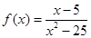

Discontinuous:
Removable discontinuities:
Intervals of continuity:

2. 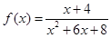
Discontinuous:
Removable discontinuities:
Intervals of continuity:

3. 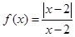
Discontinuous:
Removable discontinuities:
Intervals of continuity:

4. 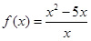
Discontinuous:
Removable discontinuities:
Intervals of continuity:

5. 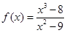
Discontinuous:
Removable discontinuities:
Intervals of continuity:

