2.02 Curve of Best Fit Additional Practice

# Heading 1

**Solve the problems below. Then, compare your answers and work to the 2.02 Curve of Best Fit Additional Practice Key.**

1. Find the standard form of a quadratic equation that has a vertex (−2, 5) and passes through the point (1, 6).

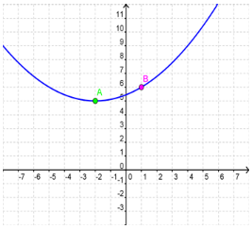

The standard form of a quadratic equation is **y = a(x – h)² + k**, so we substitute the values given into this equation.

Vertex (h, k) = (−2, 5)

Point (x, y) = (1, 6)

6 = a(      –      )**² +**

Simplify: 6 = a(     )² + 5

Simplify:       =      a

$a=\frac{ FORMTEXT }{ FORMTEXT }$

Using the vertex and the value of a, write the quadratic equation.

y = (x +      )² +

2. Write a quadratic function that has x-intercepts (1, 0 ) and (5, 0) and passes through the point (–1, 8).

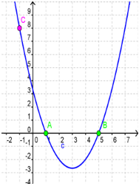

Use the intercept form of a quadratic function: y = a(x – p)(x – q) and substitute the given values into the equation.

X-intercepts: p = 1 and q = 5

Point: (x, y) = (–1, 8)

      = a(      –      )(      –      )

8 = a(     )(     )

8 =      a

a = $\frac{ FORMTEXT }{ FORMTEXT }$ = $\frac{ FORMTEXT }{ FORMTEXT }$

Using the x-intercepts and the value of a, write the quadratic equation.

y = (x –      )(x –      )

3. The results in the table show the results of a study conducted to compare the speed in miles per hour to the fuel economy in miles per gallon. Find a quadratic model for the data.

|  |  |  |  |  |  |  |
| --- | --- | --- | --- | --- | --- | --- |
| Speed | 20 | 30 | 40 | 50 | 60 | 70 |
| Fuel economy | 22 | 28 | 30 | 32 | 31 | 29 |

Insert these as **List L1** and **List L2** in your calculator or TI-83 simulator.

Next make a **scatterplot** of these points on your calculator. Sketch your graph below.

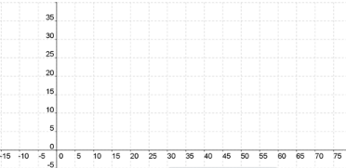

Use the **quadratic regression** feature on your calculator to find the quadratic equation for the best fit to the data.

When you hit **Enter**, your screen should look like this:

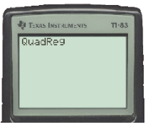

Hit **Enter** again.

Now your screen will look like this:

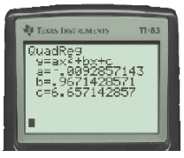

The quadratic equation is found by substituting in the values for a, b, and c. Round your answers to three decimal places.

y =      x² +      x +

Click **Y=** on your calculator and type this equation in **Y1**. Then Click **GRAPH**.

Your graph should look like this:

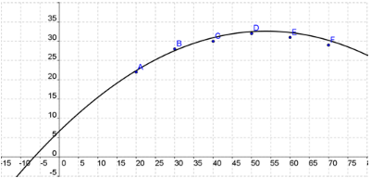

Notice that the quadratic equation is close to all the points. This means the equation is a good representation of the data.