Name:
Date:
School:
Facilitator:

1.06 Relative Minima and Maxima
Use your graphing calculator or GeoGebra to graph the following functions and then type in the points where the graph has a relative maximum or relative minimum. [Round coordinate answers to the nearest tenth.]

1. f(x) = −2x² + 4x + 4
Relative Maximum
Relative Minimum

2. h(t) = 2t³ – 6t − 6
Relative Maximum
Relative Minimum

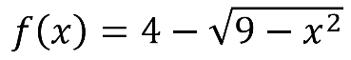
3.

Relative Maximum
Relative Minimum

4. g(x) = x³ + 3x² + 2
Relative Maximum
Relative Minimum

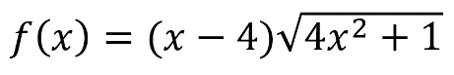
5.

Relative Maximum
Relative Minimum

