**Name:**

**Date:**

**School:**

**Facilitator:**

9.04 Sound Waves Lab

**Complete the virtual lab from PhET linked on the Task page.**

# Part 1: Wave Basics

There are 2 types of waves: transverse and longitudinal. Both types of waves can be described in terms of wavelength, frequency, and amplitude.

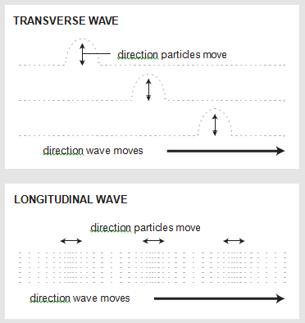

## A: Types of Waves

In this section, you will examine wave motion and determine the relationships between wavelength, frequency, and amplitude.

* In the Simulation, select a wave type. Select Water for transverse waves and Sound for longitudinal waves.
* Use the sliders to adjust frequency, and amplitude. Change the view to side view and select the graph to visualize the motion.
* Click the sound on/off button to hear or mute the sound produced by the longitudinal wave.

Answer the following questions:

1. Describe the motion of the transverse wave (Water) and the medium through which it travels. (Hint: Watch the water from the side view. Click the green button to turn on the faucet.)

1. Describe the motion of the longitudinal wave (Sound) and the medium through which it travels. (Hint: Click the option to view both waves and particles. Click the green button on the speaker to play.)

## B: Relationships Data Collection

Investigate how waves are affected by changes in frequency, and amplitude (adjust the dials). For each type of wave:

* Increase and decrease frequency. Observer the effects on wavelength and amplitude.
* Increase and decrease amplitude. Observe the effects on wavelength and frequency.
* Record your observations on the tables below.

1. Select the transverse wave (Water). Observe how each variable affects the wave and, more importantly, the other factors. In the table below, indicate decreases, increases, or no change. Click the Graph option to help visualize the wave.

|  |  |  |  |
| --- | --- | --- | --- |
| **Transverse Waves** | | | |
| **effect of** | **wavelength** | **frequency** | **amplitude** |
| **increasing frequency** |  | **N/A** |  |
| **decreasing frequency** |  | **N/A** |  |
| **increasing amplitude** |  |  | **N/A** |
| **decreasing amplitude** |  |  | **N/A** |

1. Select the longitudinal wave (Sound). Observe how each variable affects the wave and, more importantly, the other factor. In the table below, indicate decreases, increases, or no change. Click the Graph option to help visualize the wave.

|  |  |  |  |
| --- | --- | --- | --- |
| **Longitudinal Waves** | | | |
| **effect of** | **wavelength** | **frequency** | **amplitude** |
| **increasing frequency** |  | **N/A** |  |
| **decreasing frequency** |  | **N/A** |  |
| **increasing amplitude** |  |  | **N/A** |
| **decreasing amplitude** |  |  | **N/A** |

## C: Effects on Sound Data Collection

Investigate how pitch and volume are affected by changes in frequency, and amplitude.

* Use the dials to adjust the frequency, and amplitude of a sound wave.
* Change one variable at a time.
* Record your observations in the table below. Indicate: decreases, increases, or no change

|  |  |  |
| --- | --- | --- |
| **Effects of Wavelength, Frequency, and Amplitude on Sound** | | |
| **effect of** | **pitch** | **volume** |
| **increasing frequency** |  |  |
| **decreasing frequency** |  |  |
| **increasing amplitude** |  |  |
| **decreasing amplitude** |  |  |

# Part 2: Lab Analysis Questions

**Answer the following questions. Refer back to the charts above, as needed.**

1. Describe the similarities and differences between transverse and longitudinal waves.

1. Describe the relationships among wavelength, frequency, and amplitude.

1. Label each wave diagram with the appropriate terms. Each of the following terms will be used once except wavelength.
   * Amplitude
   * Compression
   * Crest
   * 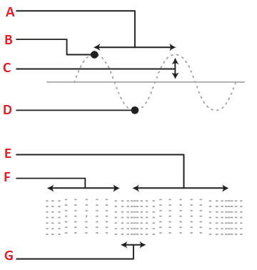Rarefaction
   * Trough
   * Wavelength

**Wave Diagrams:**