Name:
Date:
School:
Facilitator:

9.02 Label a Wave
In Parts 1 and 2, answer the following questions about the different wave illustrations.

Part 1: Transverse Waves
- Label each part of the transverse wave in the space provided.
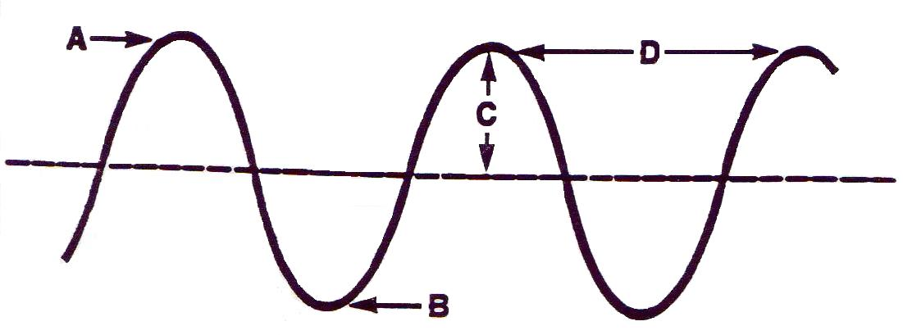

- Complete these sentences with the correct words.
  - The highest point on a transverse wave is the .
  - The lowest point on a transverse wave is the .
  - The distance from one crest to the next crest is the .
  - is a measure of the number of waves that pass a point in a given amount of time.

See Part 2 on the next page.

Part 2: Comparing Waves
Use the five illustrations of transverse waves below to answer the following questions.
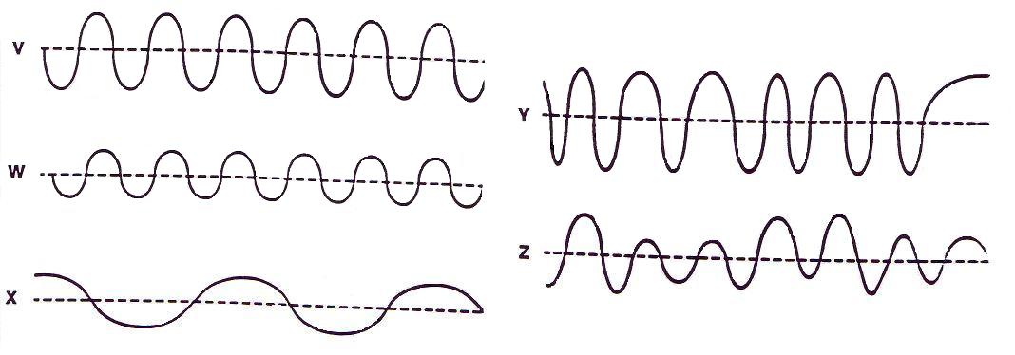

- Waves V and W have the same but wave V has twice the of wave W.
- Waves W and X have the same but wave X has half the of wave W.
- Wave shows a steady frequency but a changing amplitude.
- Wave shows a steady amplitude but a changing frequency.
- Waves and have a low amplitude and a steady frequency.
- When the particles of the medium move back and forth along the direction of the wave motion, the wave is a .
- When the particles of a medium are far apart, that part of the wave is called a .
- Compression is the part of the medium where particles are .
- A wave in which the particles of the medium move at right angles to the direction in which the wave travels is called a .

