Name:
Date:
School:
Facilitator:

8.04 Series Circuit Questions and Diagrams
Complete the following series circuit questions.

- In a simple series circuit, why does the bulb light up when you close the switch?

- In a simple series circuit, why does the bulb go out when you open the switch?

- Describe a simple series circuit.

- In a circuit diagram, what does the following symbol represent?


- In a circuit diagram, what does the following symbol represent?


- In a circuit diagram, what do the following symbols represent?
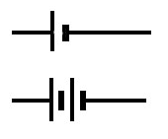

- In a circuit diagram, what does this symbol represent?
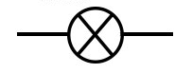

- In a circuit diagram, what does this symbol represent?


- Why is electrical wiring usually made from copper?

- Define electric circuit.

- What happens to the electric current in a series circuit when:

  - Voltage decreases:

  - Voltage increases:

  - Resistance increases:

  - Resistance decreases:

