**Name:**

**Date:**

**School:**

**Facilitator:**

2.01 Atomic Mass Math

**Fill in the appropriate values for all 6 elements. You may use the periodic table linked in the Task area to help you complete the assignment. Round all answers to the nearest whole number (Anything .4 and below, round down; anything .5 and higher, round up).**

1. Fill in the blanks to describe the following element:

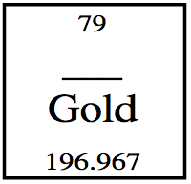

1. Atomic symbol:
2. Atomic number:
3. Atomic mass:
4. Number of protons:
5. Number of neutrons:

2. Fill in the blanks to describe the following element:

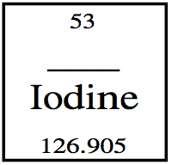

1. Atomic symbol:
2. Atomic number:
3. Atomic mass:
4. Number of protons:
5. Number of neutrons:

3. Fill in the blanks to describe the following element:

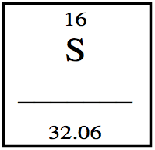

1. Element name:
2. Atomic number:
3. Atomic mass:
4. Number of protons:
5. Number of neutrons:

4. Fill in the blanks to describe the following element:

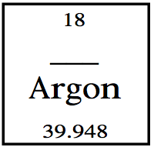

1. Atomic symbol:
2. Atomic number:
3. Atomic mass:
4. Number of protons:
5. Number of neutrons:

5. Fill in the blanks to describe the following element:

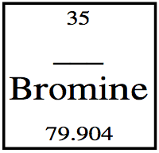

1. Atomic symbol:
2. Atomic number:
3. Atomic mass:
4. Number of protons:
5. Number of neutrons:

6. Fill in the blanks to describe the following element:

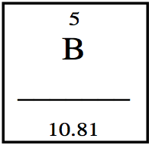

1. Element name:
2. Atomic number:
3. Atomic mass:
4. Number of protons:
5. Number of neutrons: