**Name:**

**Date:**

**School:**

**Facilitator:**

9.04 Sound Waves Lab

**Complete the virtual lab from SAS Curriculum Pathways linked on the Task page.**

The purpose of this lab is to answer the Focus Question: **“Sound waves – music to your ears or just noise?”**

Complete the lab simulation and record your answers below. The Journal in the simulation does not check your answers and will not save your answers.

# Part 1: Wave Basics

There are 2 types of waves: transverse and longitudinal. Both types of waves can be described in terms of wavelength, frequency, and amplitude.

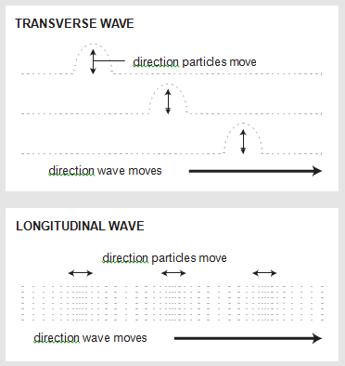

## A: Types of Waves

In this section, you will examine wave motion and determine the relationships between wavelength, frequency, and amplitude.

* In the Simulation, select a wave type.
* Use the dials to adjust wavelength, frequency, and amplitude.
* Click the sound on/off button to hear or mute the sound produced by the longitudinal wave.

Answer the following questions:

1. Describe the motion of the transverse wave (green) and the medium (red) through which it travels.

1. Describe the motion of the longitudinal wave and the medium through which it travels.

## B: Relationships Data Collection

Investigate how waves are affected by changes in wavelength, frequency, and amplitude (adjust the dials). For each type of wave:

* Lengthen and shorten wavelength. Observe the effects on frequency and amplitude.
* Increase and decrease frequency. Observer the effects on wavelength and amplitude.
* Increase and decrease amplitude. Observe the effects on wavelength and frequency.
* Record your observations on the tables below.

1. Select the transverse wave. Observe how each variable affects the wave and, more importantly, the other dials. In the table below, indicate decreases, increases, or no change.

|  |  |  |  |
| --- | --- | --- | --- |
| **Wavelength—Frequency—Amplitude Relationships** | | | |
| **Transverse Waves** | | | |
| **effect of** | **wavelength** | **frequency** | **amplitude** |
| **longer**  **wavelength** | **N/A** |  |  |
| **shorter**  **wavelength** | **N/A** |  |  |
| **increasing frequency** |  | **N/A** |  |
| **decreasing frequency** |  | **N/A** |  |
| **increasing amplitude** |  |  | **N/A** |
| **decreasing amplitude** |  |  | **N/A** |

1. Select the longitudinal wave. Observe how each variable affects the wave and, more importantly, the other dials. In the table below, indicate decreases, increases, or no change.

|  |  |  |  |
| --- | --- | --- | --- |
| **Wavelength—Frequency—Amplitude Relationships** | | | |
| **Longitudinal Waves** | | | |
| **effect of** | **wavelength** | **frequency** | **amplitude** |
| **longer**  **wavelength** | **N/A** |  |  |
| **shorter**  **wavelength** | **N/A** |  |  |
| **increasing frequency** |  | **N/A** |  |
| **decreasing frequency** |  | **N/A** |  |
| **increasing amplitude** |  |  | **N/A** |
| **decreasing amplitude** |  |  | **N/A** |

1. Which type of waves are sound waves (transverse or longitudinal)?

## C: Effects on Sound Data Collection

Investigate how pitch and volume are affected by changes in wavelength, frequency, and amplitude.

* Use the dials to adjust the wavelength, frequency, and amplitude of a sound wave.
* Change one variable at a time.
* Record your observations in the table below. Indicate: decreases, increases, or no change

|  |  |  |
| --- | --- | --- |
| **Effects of Wavelength, Frequency, and Amplitude on Sound** | | |
| **effect of** | **pitch** | **volume** |
| **longer wavelength** |  |  |
| **shorter wavelength** |  |  |
| **increasing frequency** |  |  |
| **decreasing frequency** |  |  |
| **increasing amplitude** |  |  |
| **decreasing amplitude** |  |  |

# Part 2: Interference

In this section, you will focus on sound waves as you investigate the ways in which waves can interfere with one another.

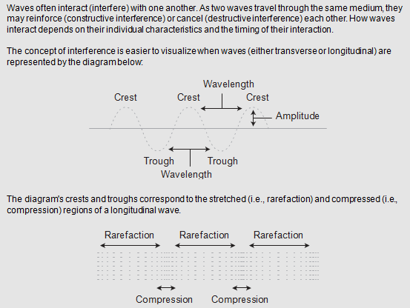

* In the Simulation (to the right), select a trial from the pull-down menu.
* Stop the waves; collect amplitude data by clicking each position (A, B, and C).
* Use the slider to adjust the sound volume.

## A: Trial 1 Data Collection

Run Trial 1. After completing Trial 1, move the dial to the Stop position:

* Click to view the amplitude data for position A.
* Use the Transfer data button to transfer this data from the Data Panel to the table.
* View and transfer the amplitude data for positions B and C.
* Analyze the data you transferred. Use the pull-down menu to indicate whether constructive interference (the waves reinforce one another), destructive interference (the waves cancel each other out), or no interference occurred.
* **Remember to add the data to the chart below.**

|  |  |  |  |
| --- | --- | --- | --- |
| **Trial 1** | | | |
| **position** | **wave** | **amplitude (m)** | **interference** |
| **A** | **1** |  | ***indicate constructive interference, destructive interference, or no interference*** |
| **2** |  |
| **1 + 2** |  |
| **B** | **1** |  |
| **2** |  |
| **1 + 2** |  |
| **C** | **1** |  |
| **2** |  |
| **1 + 2** |  |

## B: Trial 2 Data Collection

Run Trial 2. After you run Trial 2, move the dial to the Stop position:

* Click to view the amplitude data for position A.
* Use the Transfer data button to transfer this data from the Data Panel to the table.
* View and transfer the amplitude data for positions B and C.
* Analyze the data you transferred. Use the pull-down menu to indicate whether constructive interference (the waves reinforce one another), destructive interference (the waves cancel each other out), or no interference occurred.
* **Remember to add the data to the chart below.**

|  |  |  |  |
| --- | --- | --- | --- |
| **Trial 2** | | | |
| **position** | **wave** | **amplitude (m)** | **interference** |
| **A** | **1** |  | ***indicate constructive interference, destructive interference, or no interference*** |
| **2** |  |
| **1 + 2** |  |
| **B** | **1** |  |
| **2** |  |
| **1 + 2** |  |
| **C** | **1** |  |
| **2** |  |
| **1 + 2** |  |

## C: Trial 3 Data Collection

Run Trial 3. After you run Trial 3, move the dial to the Stop position:

* Click to view the amplitude data for position A.
* Use the Transfer data button to transfer this data from the Data Panel to the table.
* View and transfer the amplitude data for positions B and C.
* Analyze the data you transferred. Use the pull-down menu to indicate whether constructive interference (the waves reinforce one another), destructive interference (the waves cancel each other out), or no interference occurred.
* **Remember to add the data to the chart below.**

|  |  |  |  |
| --- | --- | --- | --- |
| **Trial 3** | | | |
| **position** | **wave** | **amplitude (m)** | **interference** |
| **A** | **1** |  | ***indicate constructive interference, destructive interference, or no interference*** |
| **2** |  |
| **1 + 2** |  |
| **B** | **1** |  |
| **2** |  |
| **1 + 2** |  |
| **C** | **1** |  |
| **2** |  |
| **1 + 2** |  |

## D: Analysis Questions (Trials 1-3)

1. When the individual waves coincide perfectly (i.e., as in Trial 2, where crest meets crest and trough meets trough), how does the amplitude at each point in the combined wave (1 + 2) compare to the amplitudes of Waves 1 and 2? Is this interference constructive or destructive?

1. When the individual waves do not coincide perfectly (i.e., as in Trial 3, where crest meets trough and trough meets crest), how does the amplitude at each point in the combined wave (1 + 2) compare to the amplitudes of Waves 1 and 2? Is this interference constructive or destructive?

1. Compare the pitch and volume of each sound (repeat Trials 1-3, as needed). Is there a connection between the type of interference you observe and the sound you hear? Explain.

## E: Trials 4 and 5 Data Collection

Sometimes, waves interact to produce partial interference that is neither completely constructive nor completely destructive. Such interference occurs when interacting waves coincide somewhat—because they are slightly "out of phase" — or when interacting waves have different frequencies (wavelengths).

Investigate partial interference by conducting Trials 4 and 5. Complete the tables below as you did for Trials 1-3.

**NOTE: When indicating the type of interference, consider the effect that Wave 2 has on Wave 1.**

|  |  |  |  |
| --- | --- | --- | --- |
| **Trial 4** | | | |
| **position** | **wave** | **amplitude (m)** | **interference** |
| **A** | **1** |  |  |
| **2** |  |
| **1 + 2** |  |
| **B** | **1** |  |  |
| **2** |  |
| **1 + 2** |  |
| **C** | **1** |  |  |
| **2** |  |
| **1 + 2** |  |

|  |  |  |  |
| --- | --- | --- | --- |
| **Trial 5** | | | |
| **position** | **wave** | **amplitude (m)** | **interference** |
| **A** | **1** |  |  |
| **2** |  |
| **1 + 2** |  |
| **B** | **1** |  |  |
| **2** |  |
| **1 + 2** |  |
| **C** | **1** |  |  |
| **2** |  |
| **1 + 2** |  |

1. Repeat Trials 1, 2, and 4; pay attention the sounds you hear. How do the sounds in Trials 2 and 4 compare to the sound from Trial 1?

# Part 3: Sound and Music

Music is produced when sound waves interfere with one another in specific ways. Not all interactions of sound waves produce music; in fact, most produce nothing but noise.

In this section, you will explore the characteristics of musical and "noisy" sounds.

* In the Simulation (to the right), select a trial from the pull-down menu.
* Use the slider to adjust the sound volume.
* When waves combine to produce music, the indicator lights up.

## A: Trials 1 – 5 Data Collection

Run each trial (1 through 5).

* Use the Transfer data button to transfer the frequency data from Data panel to the table.
* Calculate the frequency ratio by pressing the Equals button.
* Increase the volume and repeat the trials, as necessary, to compare the quality and volume of each sound.
* Use the pull-down menus to indicate the sound's characteristics.
* **Remember to record the data in the tables below!**

|  |  |  |  |  |
| --- | --- | --- | --- | --- |
| **Trial 1** | | | | |
| **wave** | **frequency** | **ratio** | **quality** | **volume** |
| **1** |  |  | ***music or noise?*** | ***loud or soft?*** |
| **2** |  |

|  |  |  |  |  |
| --- | --- | --- | --- | --- |
| **Trial 2** | | | | |
| **wave** | **frequency** | **ratio** | **quality** | **volume** |
| **1** |  |  | ***music or noise?*** | ***loud or soft?*** |
| **2** |  |

|  |  |  |  |  |
| --- | --- | --- | --- | --- |
| **Trial 3** | | | | |
| **wave** | **frequency** | **ratio** | **quality** | **volume** |
| **1** |  |  | ***music or noise?*** | ***loud or soft?*** |
| **2** |  |

|  |  |  |  |  |
| --- | --- | --- | --- | --- |
| **Trial 4** | | | | |
| **wave** | **frequency** | **ratio** | **quality** | **volument** |
| **1** |  |  | ***music or noise?*** | ***loud or soft?*** |
| **2** |  |

|  |  |  |  |  |
| --- | --- | --- | --- | --- |
| **Trial 5** | | | | |
| **wave** | **frequency** | **ratio** | **quality** | **volument** |
| **1** |  |  | ***music or noise?*** | ***loud or soft?*** |
| **2** |  |

## B: Sound and Music Question

Compare the frequency ratios for the trials resulting in music with those resulting in noise. How do the numbers they contain differ?

# Part 4: Lab Analysis Questions

Answer the following questions about the previous 3 parts of this sound waves lab. Refer back to the charts above, as needed.

## A: Wave Basic Follow-up Questions

1. Describe the similarities and differences between transverse and longitudinal waves.

1. Describe the relationships among wavelength, frequency, and amplitude.

## B: Interference Follow-up Questions

1. Label each wave diagram with the appropriate terms. Each of the following terms will be used once except wavelength.
   * 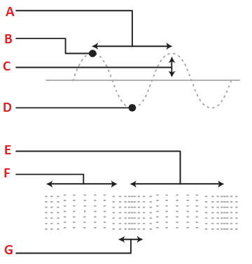Wavelength
   * Crest
   * Amplitude
   * Trough
   * Rarefaction
   * Compression

**Wave Diagrams:**



1. Explain the role interference plays, if any, in producing each sound in Trials 1-3 in Part 2: Interference.

1. How does partial interference (Trials 4 and 5 of Part 2: Interference) differ from complete interference (Trials 1-3 of Part 2: Interference)?

## C: Sound and Music Follow-up Questions

1. Musical sounds tend to be loud than noise (although irritating noises may seem louder). Use your understanding of interference to explain this observation.

1. Analyze the frequency information below. Predict which frequency combination produces music and which produces noise. Explain your predictions.

| **Frequency Combinations** | |
| --- | --- |
| **Frequencies (Hz)** | **Ratio Between Frequencies** |
| **370 and 262** | **41:29** |
| **393 and 262** | **3:2** |

## D: Conclusion

1. Think about the Focus Question: “Sound waves – music to your ears or just noise?” In answering this question, describe how sound waves can interfere with one another – constructively, destructively, and partially – and the type of sound generated by each interference pattern. Be sure to address all 3 types of interference.