**Name:**

**Date:**

**School:**

**Facilitator:**

8.07 Parallel Circuits Note-taking Guide

**Watch the video Parallel Circuits (26:36) linked on the task page. Complete the following questions in Parts 1 and 2.**

# Part 1: Questions

1. What is the danger of having too many electric devices plugged into the same outlet?

1. What is a parallel circuit?

1. Compared to a series circuit, what happens to the current when more lightbulbs are added in parallel?

1. In a parallel circuit, current      .
2. In a parallel circuit, voltage      .
3. The total resistance is       the resistance of one resistor alone.
4. The current in each branch       to the total current of circuit.
5. In a parallel circuit, the charges must go in       or the other but not      .
6. The voltage drops across resistors in each branch       the total voltage provided by the battery.
7. In a parallel circuit, the equivalent resistance is       the resistance of each resistor alone.

# Part 2: Example Calculations

**Complete the following 3 example parallel circuit calculations.**

1. 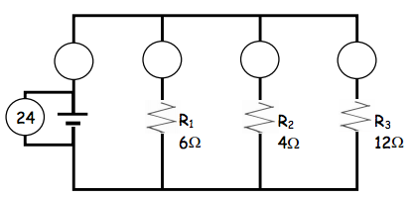

Req =       VT =       IT =

V1 =       V2 =       V3 =

I1 =       I2 =       I3 =

1. 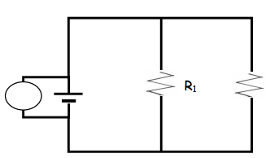

___V

___Ω

___Ω

___V

_____

Req =       IT =

V1 =       V2 =

I1 =       I2 =

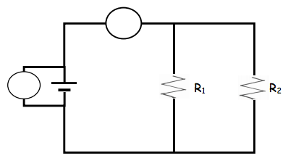

30V

30Ω

3a

___V

___V

V1 =       V2 =

I1 =       I2 =

IT =       R2 =