Name:
Date:
School:
Facilitator:

8.06 Series Circuit Calculations
Watch the video Power and Series Circuits beginning at the 24:00 minute mark. Use what you’ve learn in the video to answer the following 8 questions. You should solve the sample problems while following the video; after the video, solve the other series circuit problems. For each problem, write down the known values and then solve.
V = IR I = $\frac{V}{R}$ R = $\frac{V}{I}$

Part 1: Practice
Remember the following:
I stays the same
V adds up
R adds up

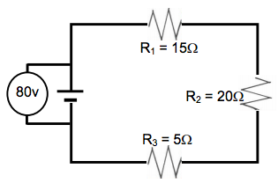
- Example Problem:
R_{T} =
V_{T} =
I_{T} =
V₁ =
V₂ =
V₃ =

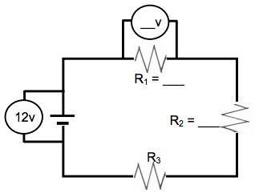
- Problem Set #3
R₁ =
R₂ =
R₃ =
I₁ =
I₂ =
I₃ =
V₁ =
V₂ =
V₃ =

Part 2: Calculations

Remember the following:
I stays the same
V adds up
R adds up
Formulas:
V = IR I = $\frac{V}{R}$ R = $\frac{V}{I}$
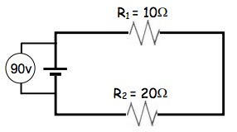

Known values: V_{T} = 90 V R₁=10 Ω R ₂= 20 Ω
R_{T}= I_{T} =
I₁ = I₂ =
V₁ = V₂=

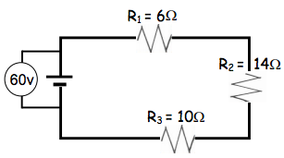

Known values: V_{T} = 60 V R₁ = 6 Ω R₂ = 14 Ω R₃ = 10 Ω
R_{T} = I_{T} =
I₁ = I₂ = I₃ =
V₁ = V₂ = V₃ =

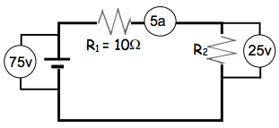

Known values:
V₁ = I₂ = R₂ =

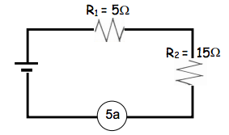

Known values:
V₁ = V₂= V_{T} =

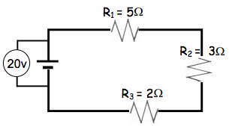

Known values:
R_{T} = I_{T} =
V₁ = V₂= V₃ =

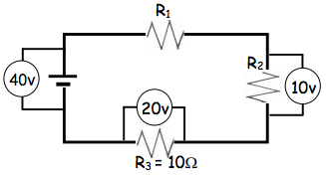

Known values:
I₁ = I₃ =
V₁ =
R₁ = R₂ =

