**Name:**

**Date:**

**School:**

**Facilitator:**

8.06 Series Circuits Note-taking Guide

**Watch the video “Power and Series Circuits” linked in the Task page. Begin at 14:00 minute mark and stop at 24:00 minute mark. Answer the following questions based on what you learn in the video.**

**Part A: Circuits**

|  |  |  |
| --- | --- | --- |
| **No. of Resistors**  **in Series Circuit** | **Brightness of Bulb (s)** | **Total I**  **(amps)** |
| **1** |  |  |
| **2** |  |  |
| **3** |  |  |

**Observations:**

1. What happened when one bulb was unscrewed?

**Conclusion:**

1. As more resistors are added to a series circuit, the total current       (increases or decreases), so total resistance       (increases or decreases).

**Part B: Current**

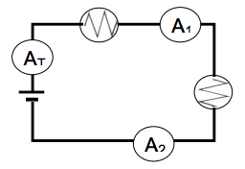

|  |  |  |  |
| --- | --- | --- | --- |
| Position | Current, I | Voltage, V | Resistance,  R = $\frac{V}{I}$ |
| Total |  |  |  |
| R1 |  |  |  |
| R2 |  |  |  |

1. Current is the       all parts of a circuit.
2. IT =

**Part C: Voltage**

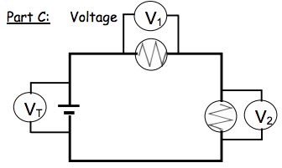

1. Voltage drops across resistors       to total voltage provided by the battery.
2. This is an example of the      .
3. VT=
4. The total resistance is found by      .
5. Total resistance is found by RT =      .

**Part D: Conclusions**

1. Within bounds of experimental error, the current in different parts of the series circuit is       (the same or different).
2. Within bounds of experimental error, the voltage drops across each resistor in this series circuit       (is the same as or adds up to) the total voltage supplied by the battery.
3. Within bounds of experimental error, the total resistance of the circuit is the       (same as, the sum of) the resistance of each bulb.