Name:
Date:
School:
Facilitator:

8.06 Circuit Questions and Diagrams
Complete the following series circuit questions. Submit your word document to the 8.04 Series Circuit Dropbox.

- In a simple series circuit, why does the bulb light up when you close the switch?

- In a simple series circuit, why does the bulb go out when you open the switch?

- Why might a bulb flash and go out when a 1.5V battery and a 3V battery are both connected across it in a simple series circuit?

- In a circuit diagram, what does the following symbol represent?


- In a circuit diagram, what does the following symbol represent?


- In a circuit diagram, what do the following symbols represent?
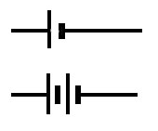

- In a circuit diagram, what does this symbol represent?
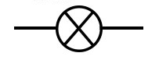

- In a circuit diagram, what does this symbol represent?
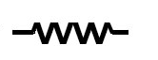

- Why is electrical wiring usually made from copper?

- Explain a series circuit.

- Write the equation to solve for current (I), resistance, (R), and voltage (V).

  - Solve for current:

  - Solve for resistance:

  - Solve for voltage:

