Name:
Date:
School:
Facilitator:

5.05 Analysis of Motion Note-taking Guide
Watch the video Analysis of Motion (30:04) and complete the following questions. For the 5.02 task, you watched the first 3:45 of the video. You may start at the 3:45 minute mark or you may start from the beginning of the video for a refresher. You will not be performing the lab shown in the video or graphing the information shown. However, later in this unit, you will be graphing calculations like the ones reviewed in the video, so be sure to pay attention and take notes below.

Part 1: Graphing Motion Notes
- In the lab, how will they determine the following?
  - To determine velocity in the lab, we can use a .
  - A paper moves through the timer while the vibrating arm makes at regular .
  - is measured with a ruler.
  - is determined by counting and multiplying by the constant time interval between dots.

Part 2: Lab Graphing
Notes after Lab Part A – when motion is UNIFORM:
- The object moves at constant in a straight .
- is constant.
- V_{avg} =
- The graph of vs is a straight line.
- The slope (or ) is constant.
- The graph of vs is a flat line.
- The slope of v vs. t graph (or ) is .
- When motion is uniform, a = .
Notes after Lab Part B – when motion is ACCELERATED:
- Velocity .
- The graph of vs is a curved line.
- The slope (or ) changes.
- V_{avg} ≠
- Acceleration is defined as: .
- Acceleration formula:
a = $\frac{ FORMTEXT }{ FORMTEXT }$
- Unit for acceleration / / or
- The slope of a velocity vs time graph is .
- slope = $\frac{Δ FORMTEXT }{Δ FORMTEXT }$ =
- When v vs t graph is a straight line (as in Part B of lab):
  - “a” is .
  - Motion is

Part 3: More Graphing
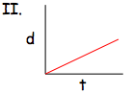
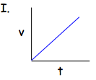

- Graph I has on the y-axis, while graph II has on the y-axis. This means that they show different things. Describe the motion of the object from each graph.
  - Graph I:

  - Graph II:

- What does slope of line represent?
  - d/t graph =
  - v/t graph =
- Look at shape (Choose best answer).
  - Straight, sloped line means slope is ( , changing, 0).
  - Curve means slope is (constant, , 0).
  - Flat line means slope is (constant, changing, ).

Put the two together (example: If slope represents “v” and shape is straight sloped line, velocity is constant, so motion is uniform.)
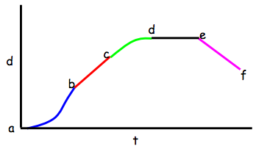

- For the graph above, explain what is happening between each point.
- a to b:
- b to c:
- c to d:
- d to e:
- e to f:
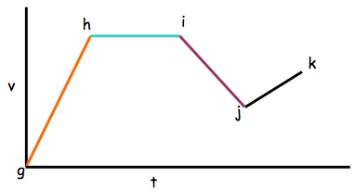

- For the graph above, explain what is happening between each point.
- g to h:
- h to i:
- i to j:
- j to k:

