Name:       School:

Date:       Facilitator:

**0.04 Equation Editor**

**Total Points: 40**

**Use your equation editor to type each expression.**

1. 

*Type your equation below.*

1. 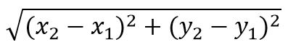

*Type your equation below.*

**Use your equation editor to type each equation or inequality.**

1. 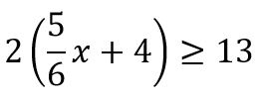

*Type your equation below.*

1. 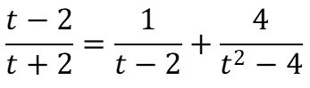

*Type your equation below.*

**Use your equation editor to type each solution.**

1. 

*Type your equation below.*

1. 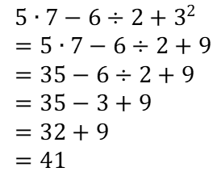

*Type your equation below.*

1. 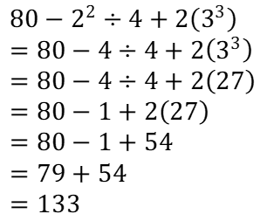

*Type your equation below.*

1. 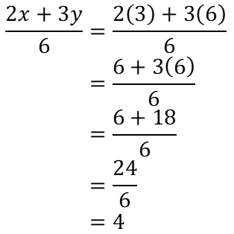

*Type your equation below.*