Name:
Date:
School:
Facilitator:

0.03 Graphing (40 points)

Sketch a Function by Hand
- Graph the following function by hand. Write the input-output values as ordered pairs. Then, draw your graph.
You can do this in one of three ways:
  - Use a sheet of graph paper or the graph paper below, a pencil, and a ruler to sketch your graph. Insert an image of your hand-drawn graph in your work.
  - Use the Scribble tool or other drawing tools in your word processing application to draw the graph.
  - Use the ACCESS Manual Graphing – Blank Grid to create your graph.

Function | Type of Function
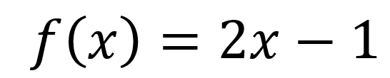 | Linear

Function: f(x) = 2x – 1
x | Calculation | y
-2 | f(x) = 2(–2) – 1 = –4 – 1 = –5 | –5
-1 | f(x) = 2(–1) – 1 = –2 – 1 = –3 | –3
0 | f(x) = 2(0) – 1 = 0 – 1 = –1 | –1
1 | f(x) = 2(1) – 1 = 2 – 1 = 1 | 1
2 | f(x) = 2(2) – 1 = 4 – 1 = 3 | 3

List your ordered pairs here:
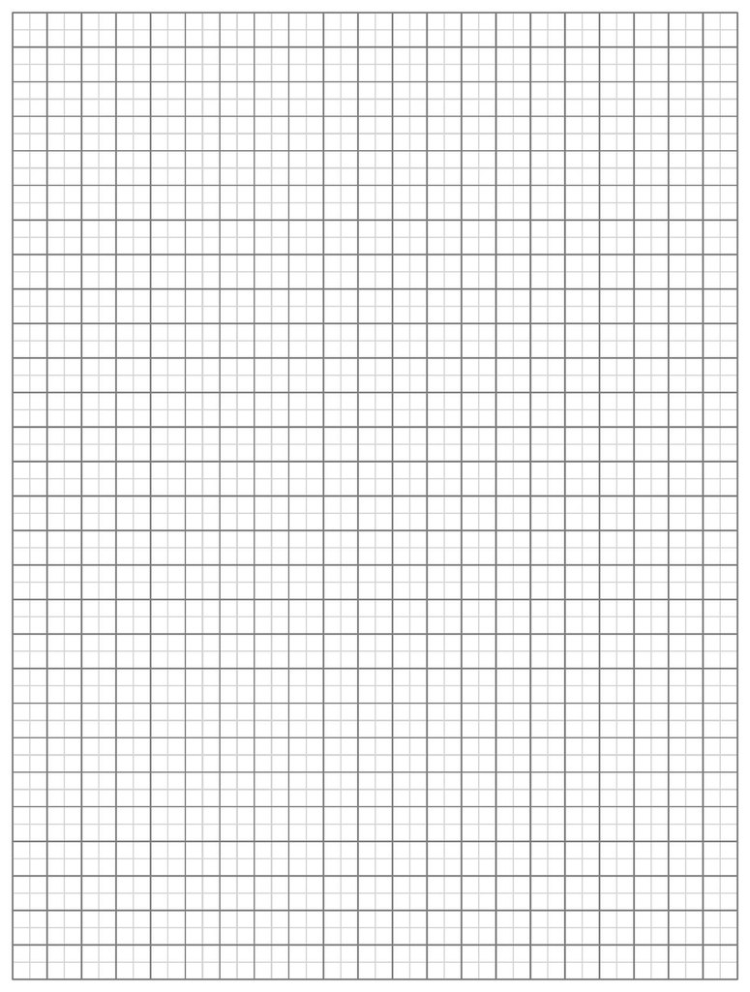

Graph a Function or Conic Section Using Technology
2. Use Desmos or GeoGebra Graphing Calculator to graph one of the following functions or conic sections. Use the links that are provided on the task page of this lesson. Copy and paste an image of the graph in the provided space below.
Function or Conic Section | Type of Function or Conic Section
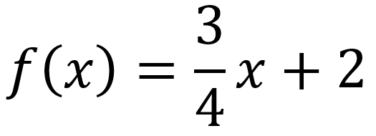 | Linear
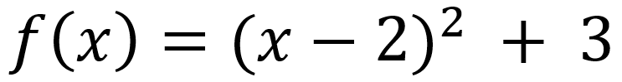 | Parabola
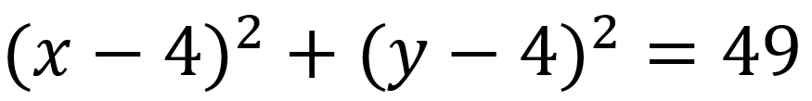 | Circle
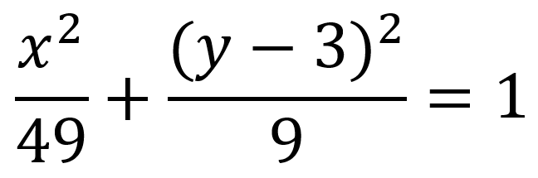 | Ellipse
 | Polynomial Function

Which function did you choose?
Insert your graph below.

