**Name:**

**Date:**

**School:**

**Facilitator:**

8.01 Party Politics

## I. Third Parties

|  |  |
| --- | --- |
| Question | Answer |
| 1. Why are Americans increasingly choosing to remain independent of the two major political parties? |  |
| 1. How do third-party candidates impact elections? |  |
| 1. How does a single-member system, rather than a proportional system, impact third parties? |  |
| 1. Why is it difficult for third parties to get on the ballot in America? |  |

II. Political Machines

Identify the following terms after reading the article [Political Machines](http://www.socialstudieshelp.com/USRA_Pol_Machines.htm) and the information from the lesson concerning party machines.

|  |  |
| --- | --- |
| Term | Definition |
| 1. Political machines |  |
| 1. Political boss |  |
| 1. Precinct, Ward, and District captains |  |

III. Analyze the cartoon  
Answer the following questions to analyze the political cartoon.

1. What do the positive aspects of the cartoon characters represent? What do the negative aspects of the cartoon characters represent?

1. Why do you think the character holding the sword is depicted positively by the cartoonist?

1. What does the artist suggest about the effect of the political machine on the people of New York?

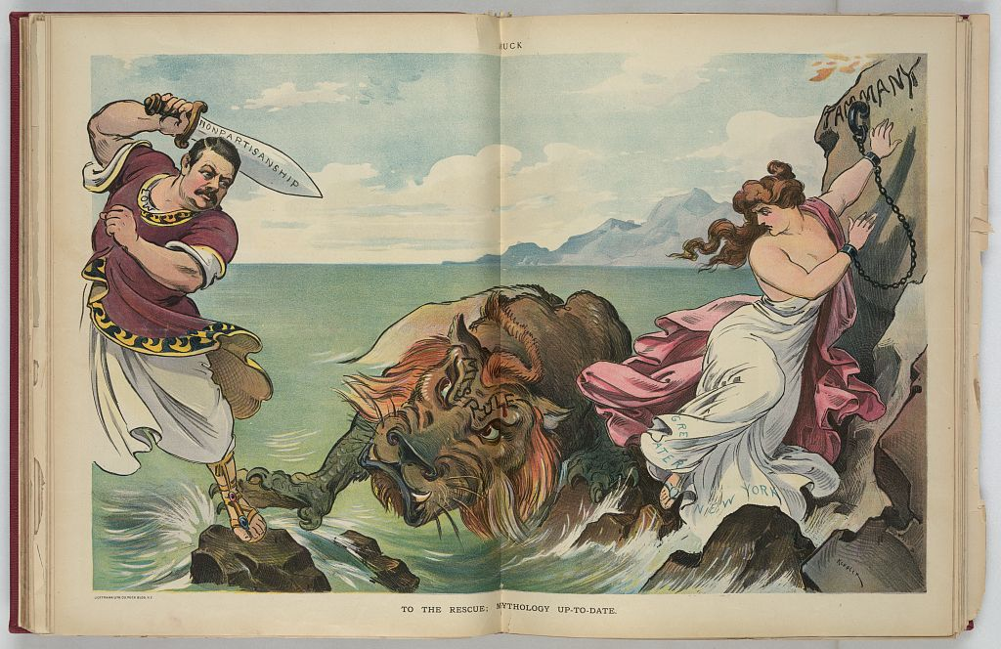

**“To the Rescue; Mythology Up-to-date”** by Keppler. The illustration shows Seth Low, possibly as Odysseus, with raised sword labeled "Nonpartisanship" about to strike a sea monster labeled "Misrule" as a woman, labeled "Greater New York", standing on rocks and chained to a rock labeled "Tammany", tries to get away from the monster. Tammany was a powerful political machine in New York during the Gilded Age. The sea monster and the rock he protects represent the political boss and political machine.