Name:        
Date:        
School:        
Facilitator:

7.04 Voter Participation

**Directions:** Complete the outline below using information from the lesson.

## I. Voter Turnout:

1. List and describe at least two reasons why eligible voters do not turnout to vote.

4. List and explain three factors associated with higher levels of political participation.

## II. Voting

1. The details concerning voter registration and qualifications are determined by each      .
2. Local election officials hire local       to assist voters, verify voter identification, and hand out ballots.
3. are available at polling places on a voluntary basis to make sure the election is being run fairly.
4. Various types of       may be used or mechanical voting machines may be utilized.
5. Citizens may also choose to mail an       instead of going to their assigned polling place.

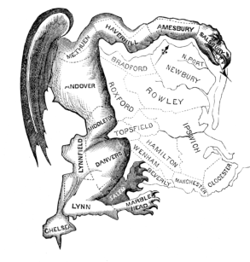III. Redistricting:Analyze the political cartoon.

8. Describe the object that stands out the most to you.

9. Does the cartoon provide a positive or negative image of redistricting? Explain your answer.

10. What is its significance to the message of the cartoon?

11. Read the background information in the Learn section about the cartoon. What is gerrymandering and where did the name originate?

12. What is reapportionment and how is it related to redistricting?