Name:

Date:

Facilitator:

School:

**7.02 Impact on Voting**

**I. Analyze the impact each of the following had on the political system of the United States with regard to the expansion of suffrage. Write your answers in complete sentences.**

1. The passage of Jim Crow Laws:

1. The Civil Rights Movement:

1. The Second Feminist Movement:

1. Explain the overall political impact of the African-American vote.

1. Explain the overall political impact of Women Voters.

**II. Analyze the image below by answering the related questions.**

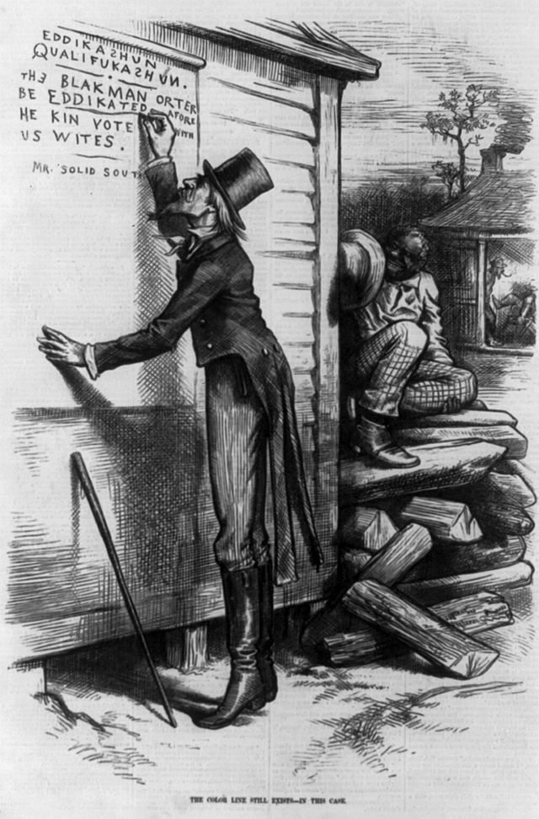6. The writing on wall in the cartoon says, "Eddikashun qualifukashun. The Black man orter be eddikated afore he kin vote with US Wites, signed Mr. Solid South." What is “Mr. Solid South” suggesting that the Black man have before he can vote?

7. Why do you think the cartoonist included spelling errors in the caption?

8. What is the main point of the cartoon?

9. Is the cartoon supportive of restrictions like literacy tests for African-American voters?

10. The man writing is dressed like Uncle Sam. What do you think this reflects about the national government’s support of the Jim Crow Laws in the South?