4.02 Majority vs. Minority Discussion Directions and Rubric 20/20 points total

The cartoon below was published in April 1909. The cartoon suggests there were disagreements, even fights, in the House of Representatives. Some things never change, especially in politics. Complete 4.02 Majority vs. Minority cartoon analysis and discussion. Post your completed work to the **4.02 Majority vs. Minority Discussion**. Be sure to post your additional response to a classmate’s post.

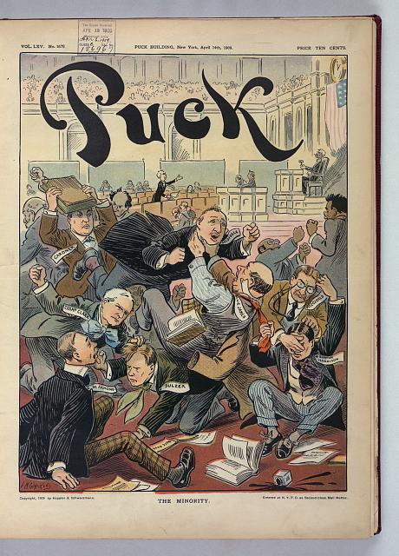

<http://www.loc.gov/pictures/item/2011647456/> **Title:**The minority / L.M. Glackens.

Analyze the cartoon before you post your discussion. Answers will vary.

1. Who are the people fighting in the cartoon?

2. Why do you think the cartoon is titled, “The Minority”?

3. Why would the “Minority” in Congress have to fight?

**Original Discussion Post:**

Now that you have analyzed the cartoon, post your response to the questions below to the **4.02 Majority vs. Minority Discussion**. Be sure to answer thoughtfully in at least 5 to 6 sentences using material from the lesson to help support your answer.

* How does Congress today compare to the Congress portrayed by the cartoonist?
* Do you think politicians in Congress fight too much today?
* Do you think the structure and the system of rules in the House of Representatives is fair for both parties? Why or why not?
* Provide one way to improve conflicts among the majority and minority parties in the House of Representatives.

Criteria

* Using 5-6 sentences
* Using thoughtful answers
* Reference material from lesson
* State an opinion

**12 points** - if all of the above criteria are met

**9 or 10 points** - if the student failed to fully comply with one of the elements

**6 or 7 points** - if the student failed to fully comply with two or more elements

**Response Post 1**

Respond to the thoughts of one classmate’s post with whom you agree in **4.02 Majority vs. Minority Discussion** by writing at least 2 sentences explaining why you agree with his or her post. Be sure to share a reason for your support that is not mentioned in his or her post.

Criteria

* Using at least 2 sentences
* Using thoughtful answers
* Reference material from lesson
* State an additional opinion

**4 points** - if all of the above criteria are met

**3 points** - if the student failed to fully comply with one of the elements

**2 points** - if the student failed to fully comply with two or more elements

**Response Post 2**

In addition, respond to the thoughts of one classmate’s post with whom you disagree in **4.02 Majority vs. Minority Discussion** by writing at least 2 sentences explaining why you disagree with his or her post. Be respectful and have evidence to support your statements.

Criteria

* Using at least 2 sentences
* Using thoughtful answers
* Reference material from lesson
* State an additional opinion

**4 points** - if all of the above criteria are met

**3 points** - if the student failed to fully comply with one of the elements

**2 points** - if the student failed to fully comply with two or more elements