Name:
Date:
School:
Facilitator:

8.01 Party Politics

I. Third Parties
Question | Answer
- Why are Americans increasingly choosing to remain independent of the two major political parties?
- How do third-party candidates impact elections?

- How does a single-member system, rather than a proportional system, impact third parties?
- Why is it difficult for third parties to get on the ballot in America?

II. Political Machines: Identify the following terms after reading the article Political Machines and the information from the lesson concerning party machines.
Term | Definition
- Political machines
- Political boss

- Precinct, Ward, and District captains

III. Analyze the cartoon: Answer the following questions to analyze the political cartoon.
- What do the characters are depicted positively by the artist represent? Negatively?

- Why do you think the character holding the sword is depicted positively by the cartoonist?

- What does the artist suggest about the effect of the political machine on the people of New York?

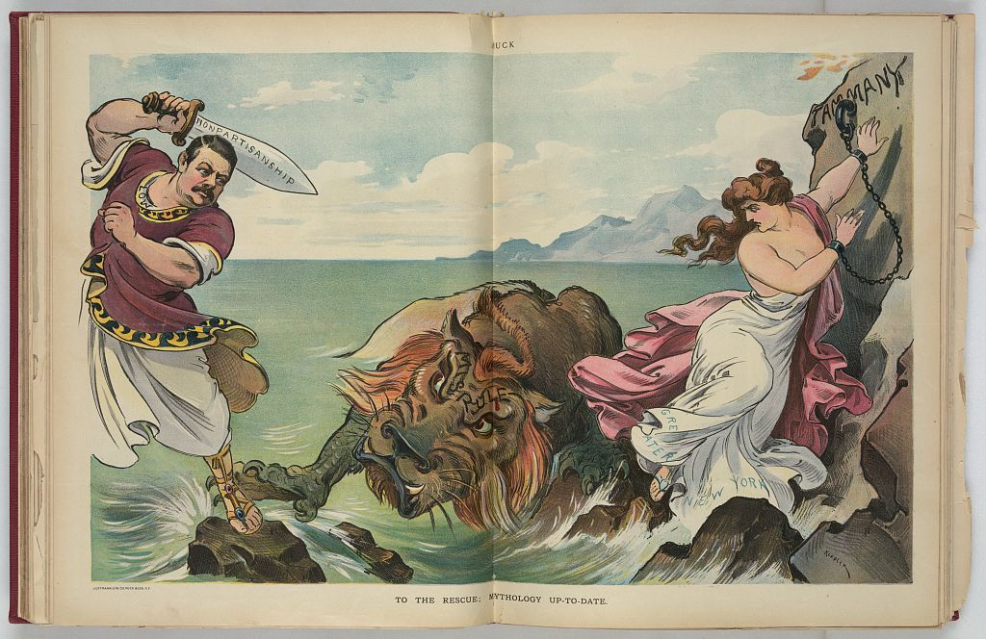
“To the Rescue; Mythology Up-to-date” by Keppler. The illustration shows Seth Low, possibly as Odysseus, with raised sword labeled "Nonpartisanship" about to strike a sea monster labeled "Misrule" as a woman, labeled "Greater New York", standing on rocks and chained to a rock labeled "Tammany", tries to get away from the monster. Tammany was a powerful political machine in New York during the Gilded Age. The sea monster and the rock he protects represent the political boss and political machine.

