Name:
Date:
Facilitator:
School:
7.01 Expansion of Suffrage
I. Analyze the impact each of the following had on the political system of the United States with regard to the expansion of suffrage. Write your answers in complete sentences using correct grammar and spelling.
- The abolition of property as a requirement for voting:

- The passage of the Fifteenth Amendment:

- The passage of black codes:

- The passage of the Nineteenth Amendment:

- The passage of the Twenty-Sixth Amendment:

II. Analyze the photograph below by answering the related questions.

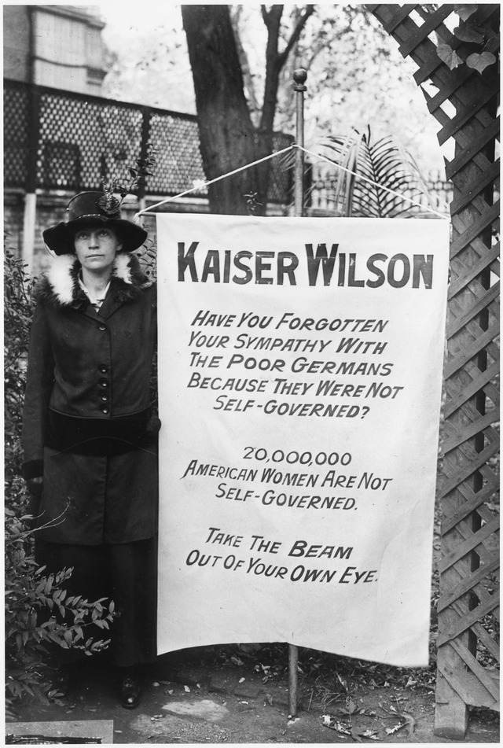
1. When do you think the photo was taken? Explain. Hint: The banner is addressed to “Kaiser” Wilson.
2. What does the woman want President Wilson to do and why?
3. The photograph was taken while a World War was taking place. How do you think the public would have reacted to the women who were protesting in front of the White House during this time?
4. If the 20,000,000 women referred to on the banner had gotten what they were demanding, how might elections have been impacted in America?
5. What changes concerning voting rights did these types of protests eventually lead to?
Watch THE FIGHT FOR WOMEN’S SUFFRAGE (2:20) to learn more about the results of the protests in front of the White House.

