Name:
Date:
School:
Facilitator:

3.06 Applications of the Pythagorean Theorem

Solve each of the following problems. Show all work and write your final answer in the appropriate space. Do not forget to include units.

1. | Televisions are usually advertised by the length of their diagonal. How should a television be advertised if it is 28 inches long and 22 inches wide? Round your answer to the nearest tenth. | 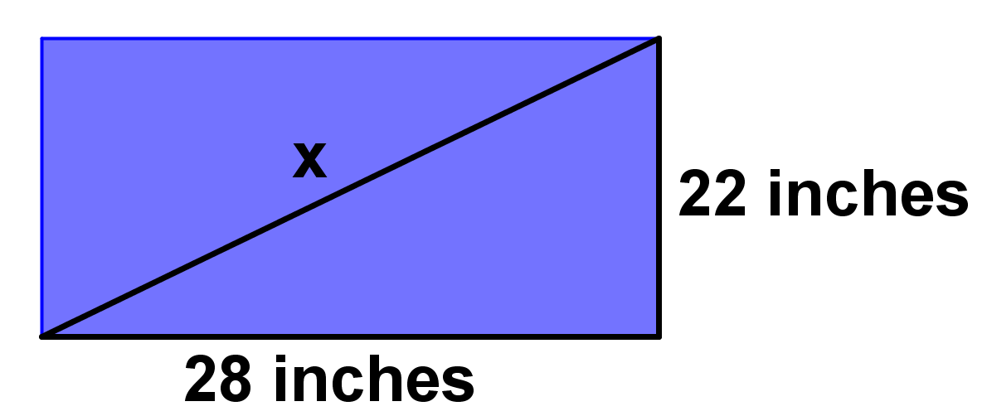
 | Show work here:
 | The television should be advertised as a television.

2. | On a baseball field, it is 90 feet between bases. Determine the distance from home plate to second base. Then determine if this is the same as the distance from third base to first base. | 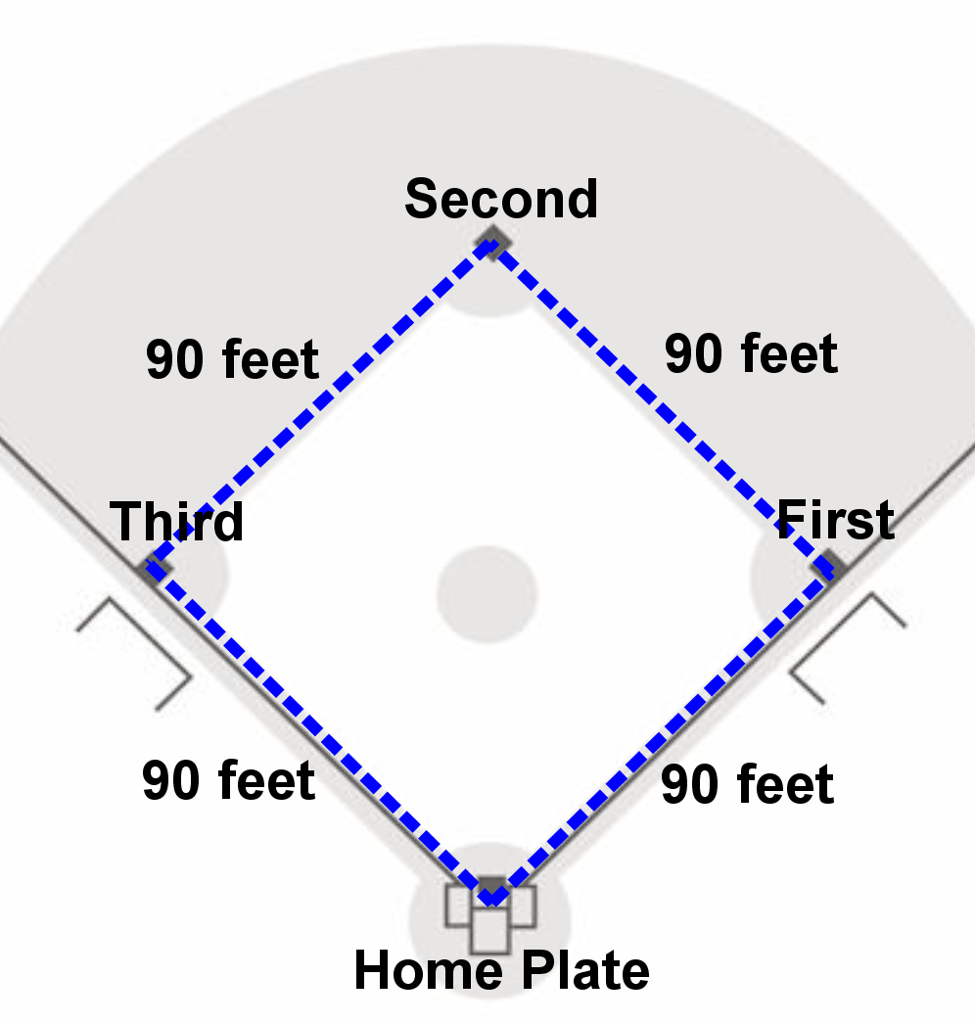
 | Show work here for home plate to second base:
 | Show work here for first base to third base:
It is from home plate to second base.

It is from third base to first base.

Are the two distances the same? (Yes/No)

3. | A young man is 36 meters away from a building and looking at a bird sitting on top of the building. The man knows he is 85 meters away from the bird. How tall is the building? | 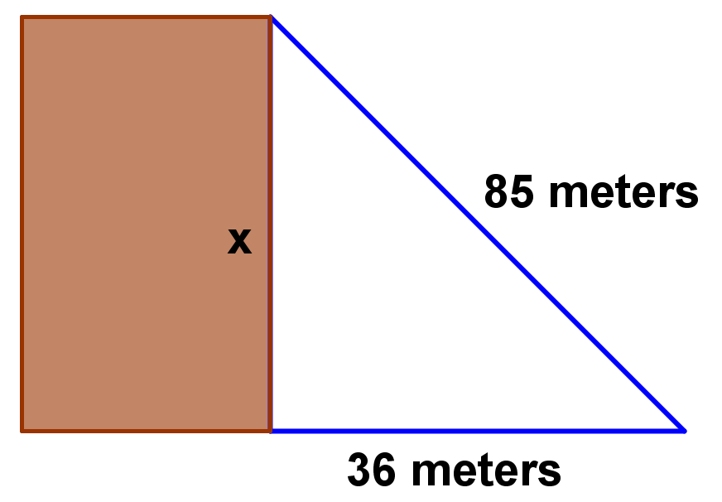
 | Show work here:
 | The building is tall.

4. | The doorway of a family room measures 78 inches by 36 inches. What is the length of the diagonal? | 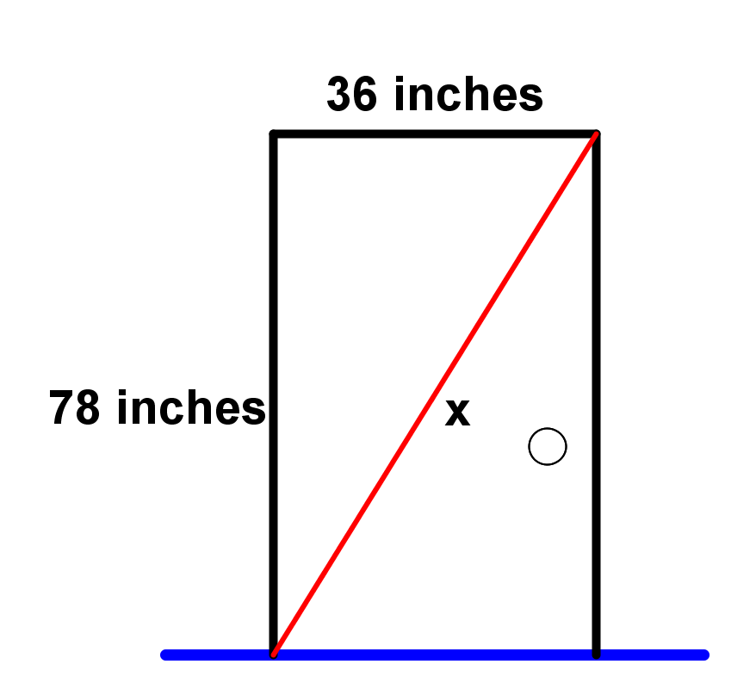
 | Show work here:
 | The length of the diagonal is .

5. | You are asked to construct a ramp going into your front door. The bottom of the door is 3 feet from the ground. The ramp must be at least 8 feet long. How far will the bottom of the ramp be from the door? | 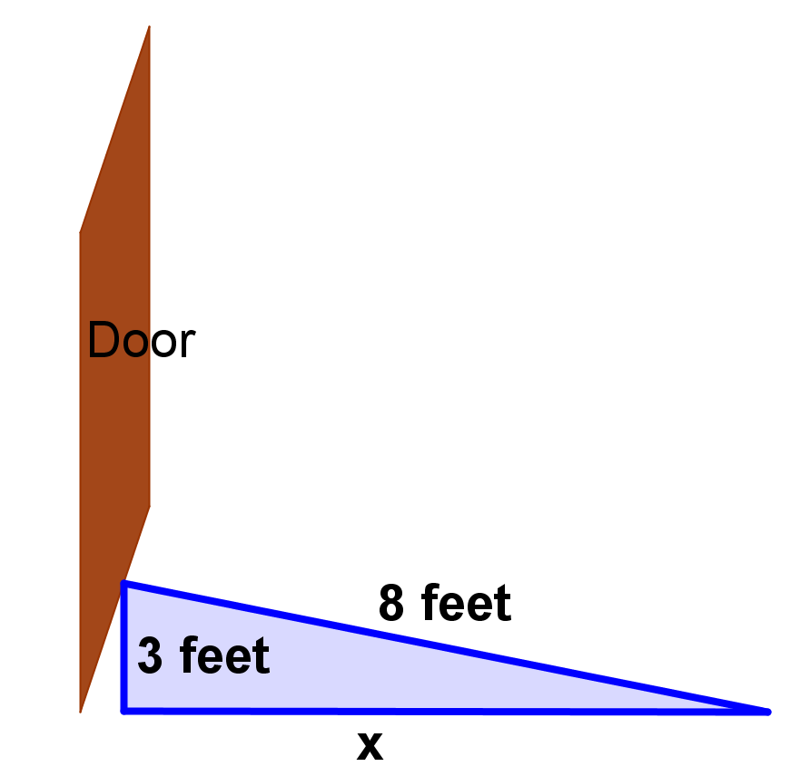
 | Show work here:
 | The bottom of the ramp will be from the door.

