Name:
Date:
School:
Facilitator:

3.05 Special Right Triangles: 30°-60°-90°

Solve for the variable(s). To enter (√) you may simply type “sqrt”.

1. | 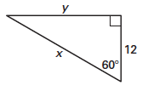
 | Because the triangle is a °- °-90° triangle, the longer leg (y) is times the length of shorter leg (12) and the hypotenuse (x) is times the length of the shorter leg (12).
 | x =
 | y =

2. | 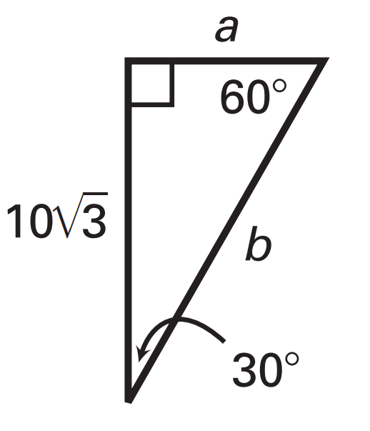
 | Because the triangle is a °- °-90 ° triangle, the longer leg ( ) is times the length of shorter leg ( ) and the hypotenuse ( ) is times the length of the shorter leg (a).
 | a =
 | b =

**continued on the following page**

3. | 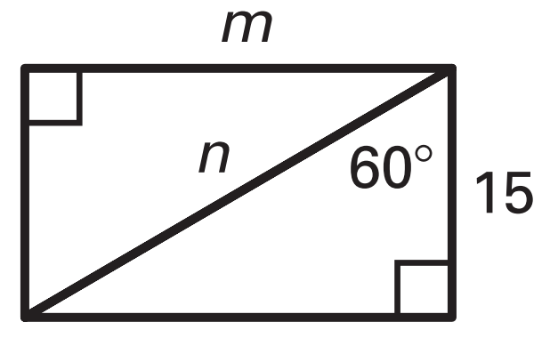
 | Because the triangle is a °- °-90 ° triangle, the longer leg ( ) is times the length of shorter leg (15) and the hypotenuse ( ) is times the length of the shorter leg ( ).
 | m =
 | n =

4. | 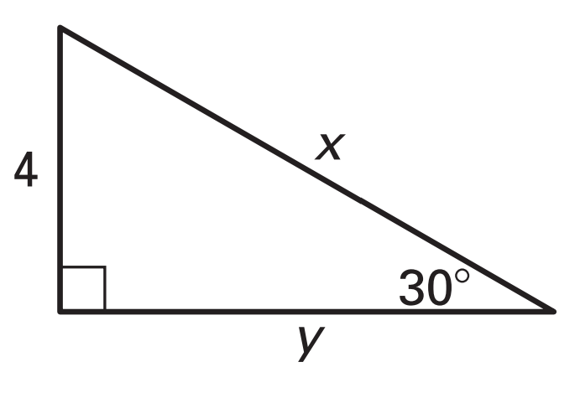
 | x =
 | How did you determine the value of x?
 | y =
 | How did you determine the value of y?

5. | 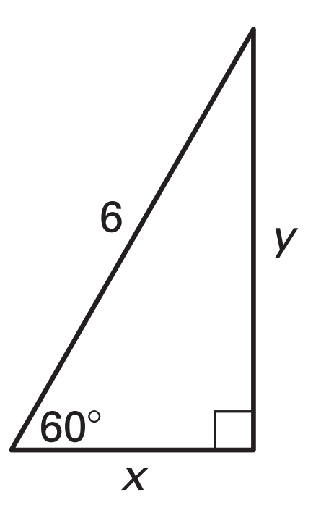
 | x =
 | How did you determine the value of x?
 | y =
 | How did you determine the value of y?

