Name:
Date:
School:
Facilitator:

3.03 Converse of the Pythagorean Theorem

Fill-in-the-blank with the correct type of triangle described. You should choose between right, obtuse, and acute.

1. c² > a² + b² indicates a(n) triangle.

2. c² < a² + b² indicates a(n) triangle.

3. c² = a² + b² indicates a(n) triangle.

Classify each triangle as right, acute, or obtuse. You must show ALL work to receive credit.

4. | 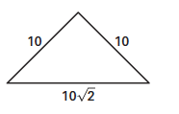
 | Show your work here:
 | This triangle is a(n) triangle.

5. | 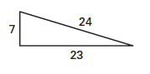
 | Show your work here:
 | This triangle is a(n) triangle.

6. | 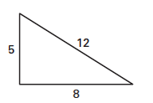
 | Show your work here:
 | This triangle is a(n) triangle.

7. | 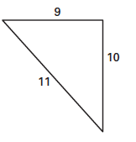
 | Show your work here:
 | This triangle is a(n) triangle.

8. | 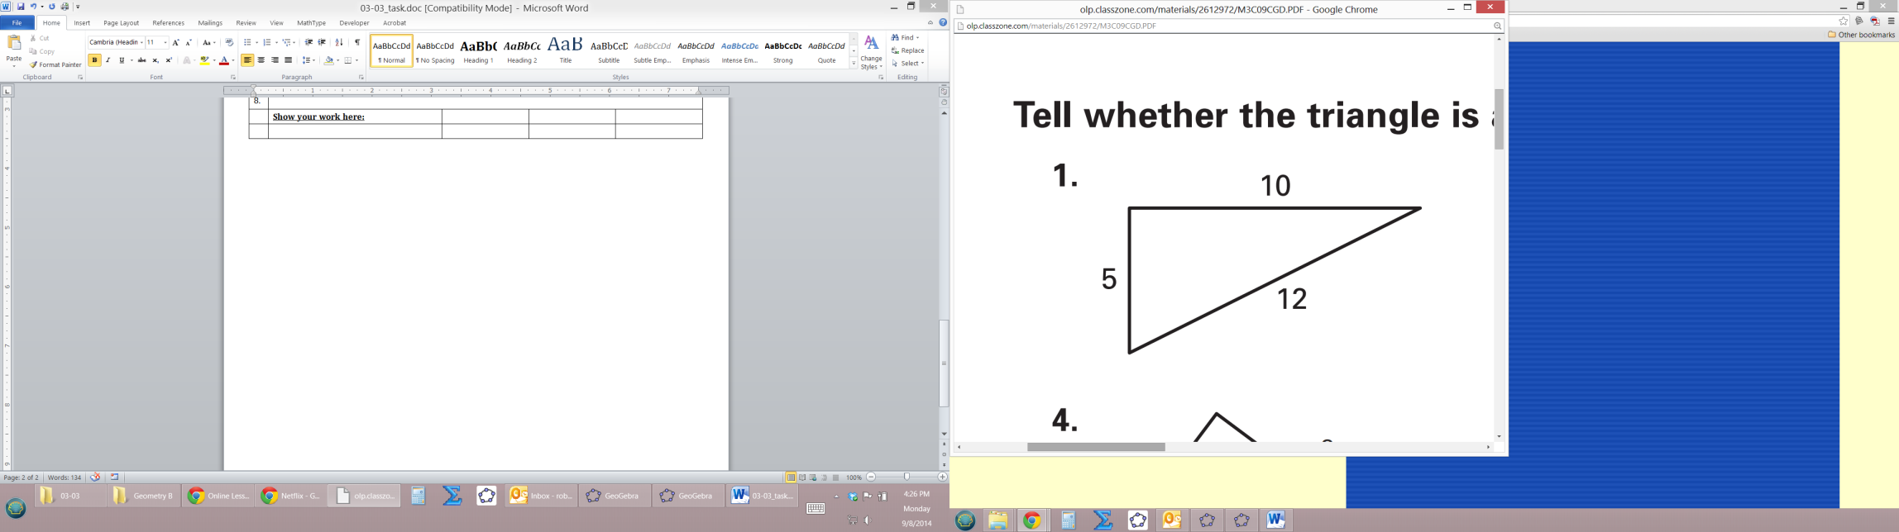
 | Show your work here:
 | This triangle is a(n) triangle.

9. | 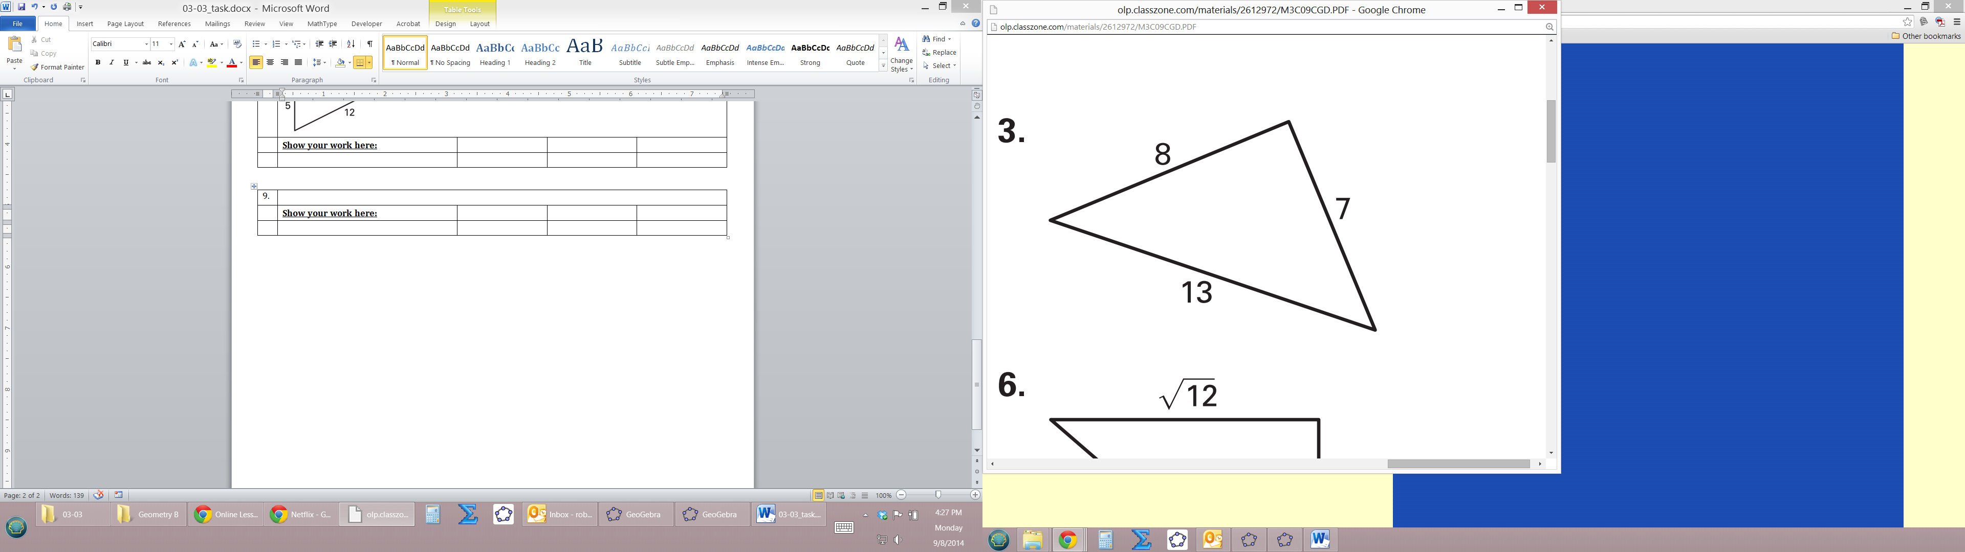
 | Show your work here:
 | This triangle is a(n) triangle.

10. | 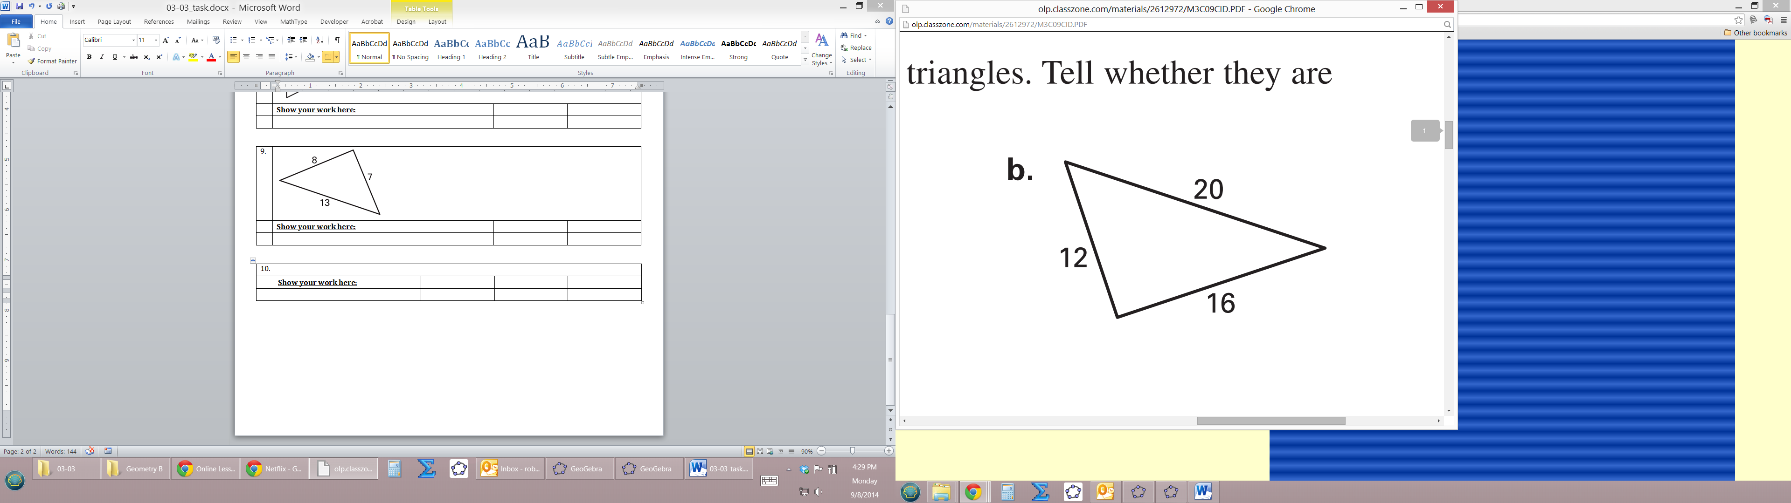
 | Show your work here:
 | This triangle is a(n) triangle.

