Name:
Date:
School:
Facilitator:

2.05 Triangle Similarity: SSS and SAS

1. | Look at the triangles and decide who has chosen the triangle that is similar to ΔEFG? And why?  Jack says triangle A and Jill says triangle B.
 | 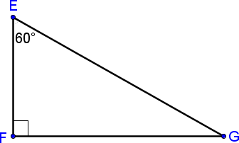
 | 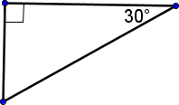  A | 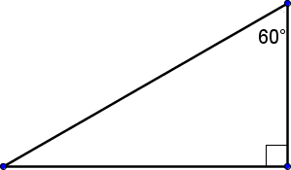  B | 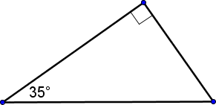  C
 | Answer:
 | Why?

2. | Decide whether ΔABC and ΔDEF are similar, not similar, or cannot be determined for the given information. Include your reasoning.
 | 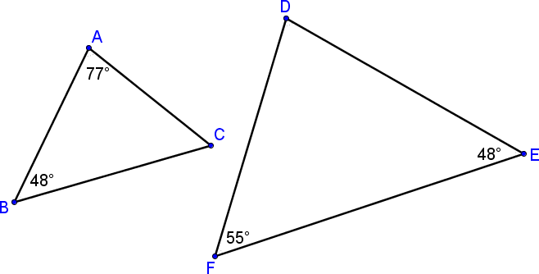
 | Answer:

**continued on the next page**

3. | The triangles shown are similar. List all pairs of congruent angles and write the statement of proportionality.  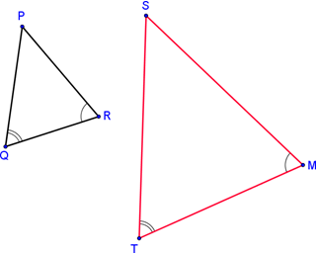
 | ∠ ≅∠ |  |  | ∠ ≅∠ |  |  | ∠ ≅∠
 |  | = |  |  | =

Determine if the triangles are similar. If they are:
a. List the congruent angles (if applicable).
b. Set-up a statement of proportionality for known sides.
c. Write a similarity statement in form ΔABC ~ ΔDEF.
4. | 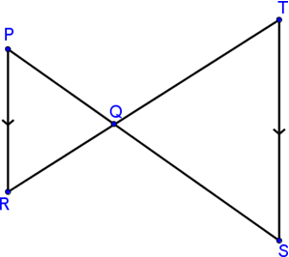
 | Are the triangles similar?
 | If yes, which angles are congruent?
 | ∠ ≅∠ |  |  |  |  |  | ∠ ≅∠ |  |  |  |  |  | ∠ ≅∠
 | Set-up the statement of proportionality for known sides.
 |  |  | = |  |  |  | =
Complete the similarity statement:
By the Similarity Theorem, Δ ~ Δ

5. | 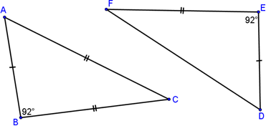
 | Are the triangles similar?
 | If yes, which angles are congruent?
 | ∠ ≅∠ |  |  | ∠ ≅∠ |  |  | ∠ ≅∠
 | Set-up the statement of proportionality for known sides.
 |  | = |  | =
Complete the similarity statement:
By the Similarity Theorem, Δ ~ Δ

6. | 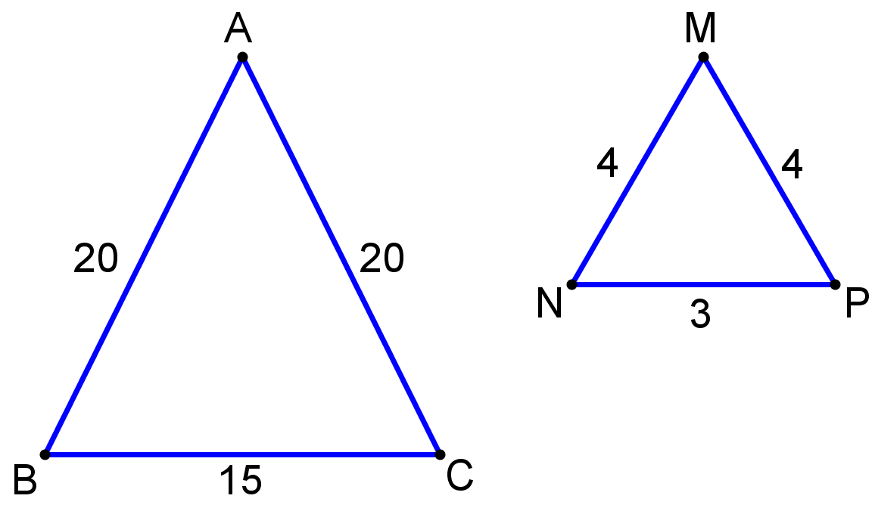
 | Are the triangles similar?
 | If yes, which angles are congruent?
 | ∠ ≅∠ |  |  | ∠ ≅∠ |  |  | ∠ ≅∠
 | Set-up the statement of proportionality for known sides.
 |  | = |  | =
Complete the similarity statement:
By the Similarity Theorem, Δ ~ Δ

