Name:
Date:
School:
Facilitator:

8.06 Compositions
Total Points: 25
The vertices of $∆$ABC are A(3,2), B(8,8), C(8,2). Graph the image of $∆$ABC after the composition of the transformations in the order they are listed.

- Rotation: ${90}^{0}$ clockwise about the origin
Translation: $(x,y)→(x-10,y+9)$

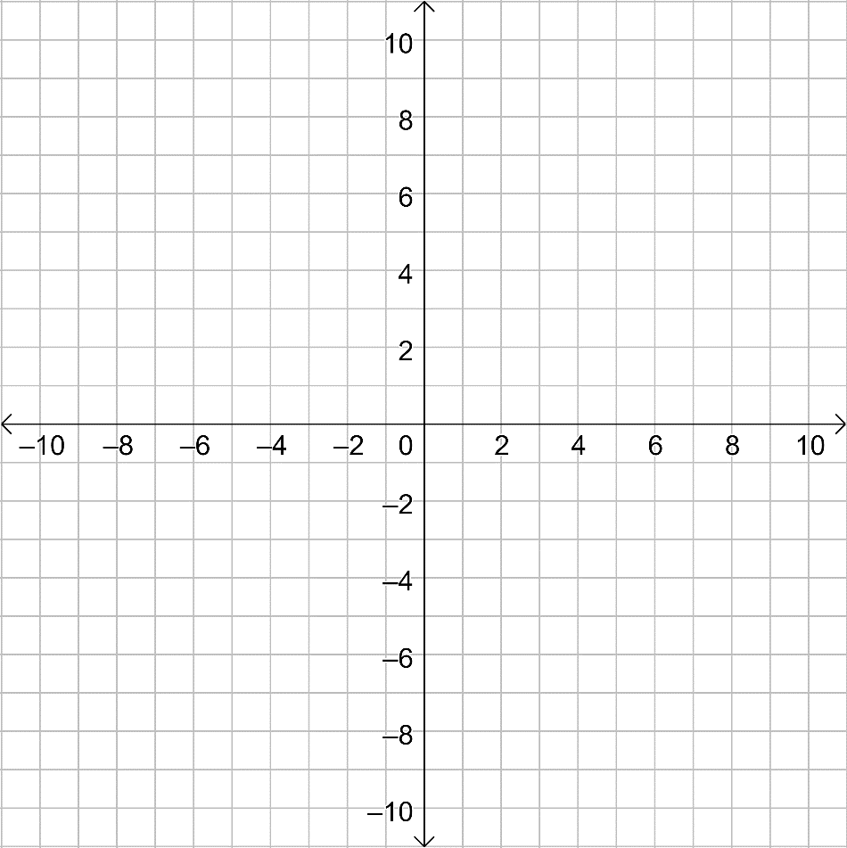

- Reflection: x-axis
Translation: $(x,y)→(x-12,y-2)$

Segment DE has endpoints D(-9,5) and E(-6,7). Graph the image of $segment AB$after the composition of the transformations in the order they are listed.
- Reflection: $x$ = -3
Reflection: $x$ = 4
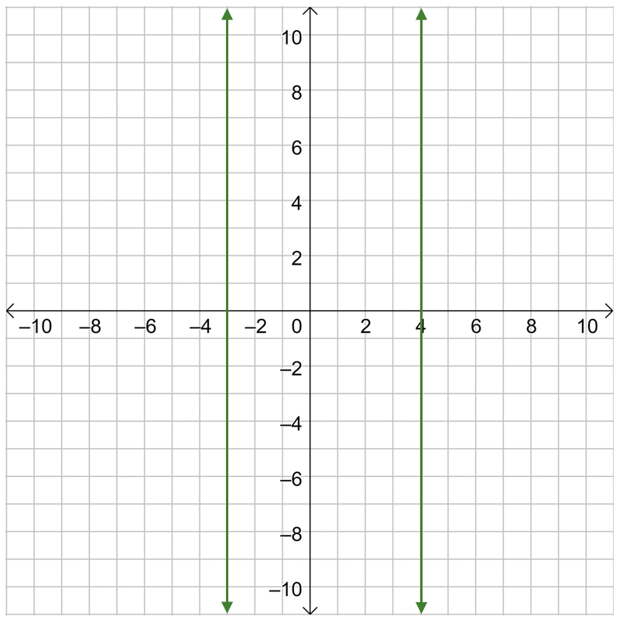

The vertices of $∆$FGH are F(-10,7), G(-7,4), H(-5,4). Graph the image of $∆$FGH after the composition of the transformations in the order they are listed.

- Reflection: $x$ = -4
Reflection: y = $x$

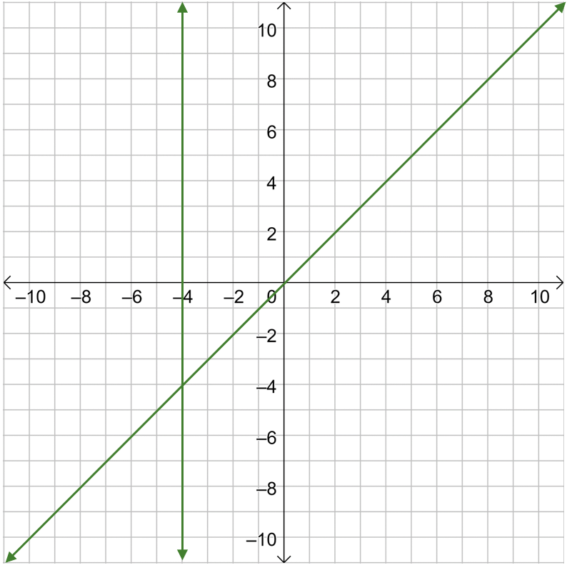

Determine if polygon CDGH and polygon JKLM are congruent by using a composition of transformations. Show the composition of the transformations on the given coordinate plane. The coordinates of polygon CDGH are C(-10,8), H(-5,6), G(-4,4), and H(-5,6). The coordinates of polygon JKLM are J(1,-8), K(2,-4), L(7,-4), and M(6,-6).

- Answer:

