Name:
Date:
School:
Facilitator:

8.02 Translations
Total Points: 44
Identify which of the figures represent isometries. Write “yes” or “no” in the blank provided.

1. | 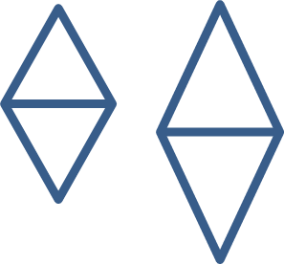 |  | 2. | 
3. |  |  | 4. | 
5. |  |  | 6. | 

Determine the number of units a given figure would be translated using the given notation.

7. | (x, y) (x + 7, y – 6) |  | 8. | (x, y) (x – 9, y + 2)
 | units (left/right) |  |  | units (left/right)
 | units (up/down) |  |  | units (up/down)
9. | (x, y) (x – 11, y) |  | 10. | (x, y) (x – 8, y – 5)
 | units (left/right) |  |  | units (left/right)
 | units (up/down) |  |  | units (up/down)
11. | (x, y) (x + 13, y + 3) |  | 12. | (x, y) (x, y + 9)
 | units (left/right) |  |  | units (left/right)
 | units (up/down) |  |  | units (up/down)
13. | (x, y) (x – 14, y + 12) |  | 14. | (x, y) (x, y – 4)
 | units (left/right) |  |  | units (left/right)
 | units (up/down) |  |  | units (up/down)

Using the figures below, determine the coordinates of the new figure.

15. | 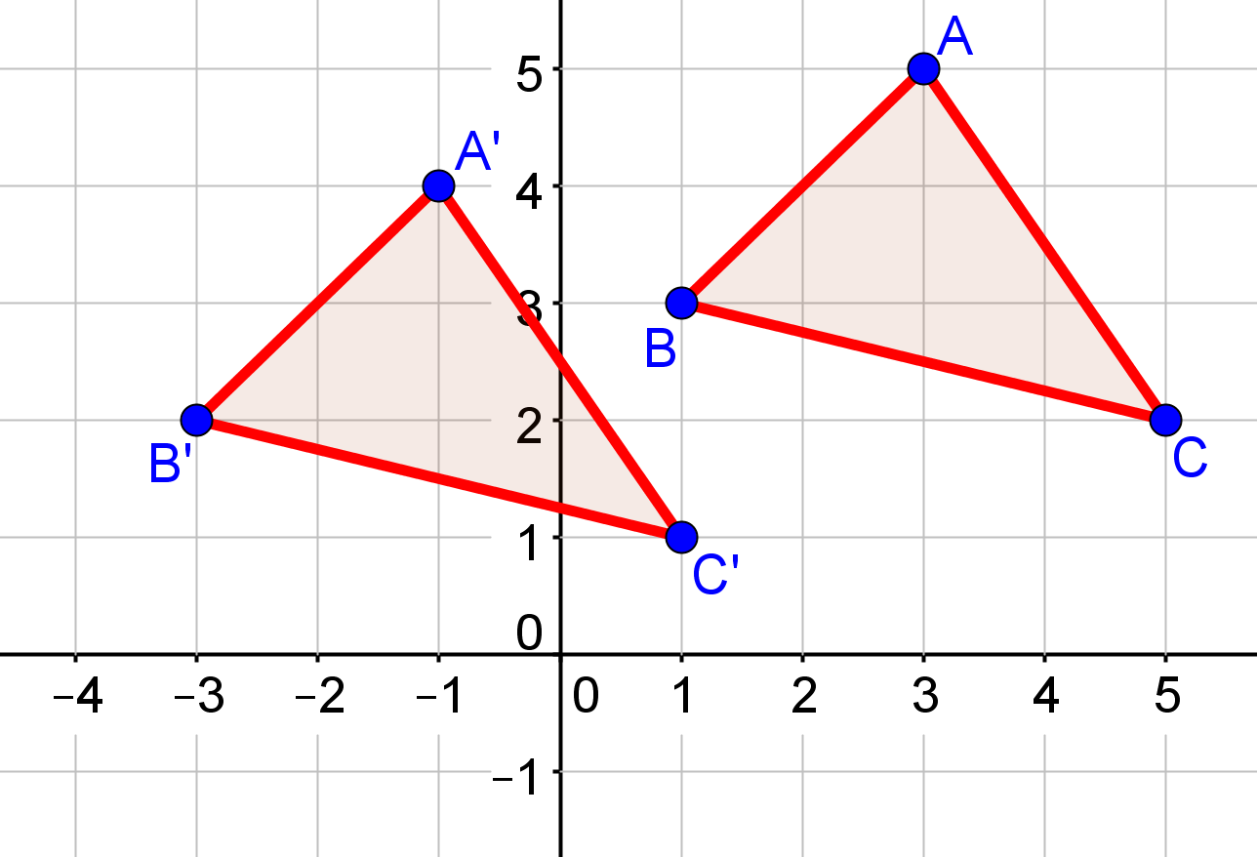 | A(3, 5) → A’( , )
 |  | B(1, 3) → B’( , )
 |  | C(5, 2) → C’( , )

