Name:
Date:
School:
Facilitator:

7.06 Trapezoids
Total Points: 28
- Find the angle measures of the missing angles.
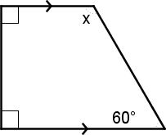
x =

- SegmentT is the midsegment of the trapezoid. Find x.
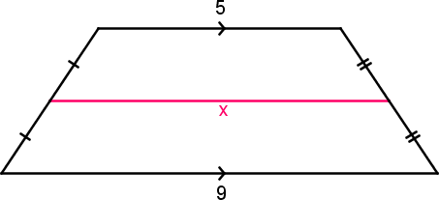
SR
T
x =
- Segment RT is the midsegment of the trapezoid. Find x.
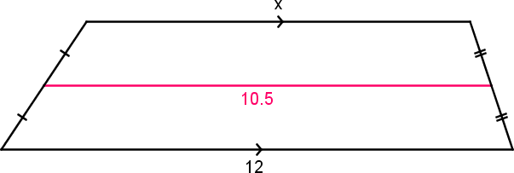
R
T
x =
- Find the midsegment of trapezoid ADCB given that A(1,1), D(5,1), C(4,8), and B(2,8).
a. State the coordinates of the endpoints of the midsegment. Show your work!
( , ) and ( , )
b. Verify that the midsegment is parallel to the bases of ADCB. Show your work!
Slope of AD =
Slope of BC =
Slope of midsegment =
c. Verify that the length of the midsegment is half the sum of the lengths of the bases. Again, Show your work.
Length of AD =
Length of BC =
Sum of length of bases:
Length of midsegment:

