Name:
Date:
School:
Facilitator:

6.06 Trapezoids Study Guide
Match the terms to their definitions.

1. Quadrilateral
2. Base Sides
3. Legs
4. Trapezoid
5. Midsegment
6. Diagonals

a. The two parallel sides of a trapezoid
b. Line segments that connect two non-adjacent vertices
c. A segment that connects the mid-points of the legs of a trapezoid
d. A four-sided polygon
e. A quadrilateral with exactly one set of parallel sides
f. The two non-parallel sides of a trapezoid

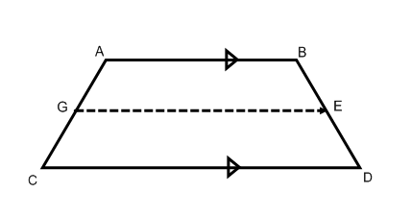
7. In trapezoid ABDC, if m∠CAB=125°, solve for ∠ACD. m∠ACD = °
8. In trapezoid ABDC, if AB = 18 and CD = 24, solve for the mid-segment GE. GE =
9. In trapezoid ABDC, if GE is a midsegment and ED = 9, find the measure of BD. BD =
10. In isosceles trapezoid ABDC, find the measure of AC if BD = 10. AC =
11. In isosceles trapezoid ABDC, if m∠EDC=44°, find the measure of ∠ACD and ∠DBA.
m∠ACD = °
m∠DBA = °

Imagine a trapezoid MNOP, where M(9,1), N(7,7), O(3,7) and P(3,1)

12. Find the coordinates of a midsegment for this trapezoid.
( , ) and ( , )
13. Find the measure of the bases MP and NO
MP = and NO =

14. Find the measure of the midsegment two ways, by using the mid-segment formula and with the distance formula.
midsegment =

