Name:
Date:
School:
Facilitator:

7.04 Proving Quadrilaterals are Parallelograms
Total Points: 26
Problems #1-5 are worth 2 points: 1 point per answer blank.
Problems #6-7 are worth 8 points each: 3 points for statement summary and 5 points for work.

Is there enough information to prove the quadrilateral is a parallelogram? Explain your reasoning.

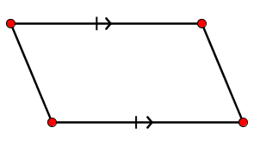 |  | 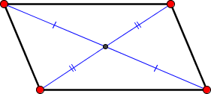
1. Is it a parallelogram, or can you tell?  Explanation: |  | 2. Is it a parallelogram, or can you tell?  Explanation:
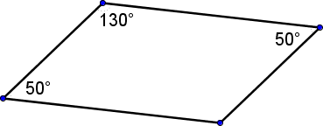 |  | 
3. Is it a parallelogram, or can you tell?  Explanation: |  | 4. Is it a parallelogram, or can you tell?  Explanation:
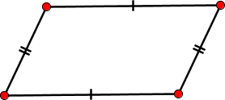
5. Is it a parallelogram, or can you tell?
Explanation:

6) Show that C (2, -1), D (1, 3), E (6, 5), F (7, 1) are vertices of a parallelogram. Show your work.
Summary Statement:
Show your work below.

7) Show that A (2, 5), B (8, 4), C (9, -4), D (3, -3) are vertices of a parallelogram. Show your work.
Summary Statement:
Show your work below

