Name:
Date:
School:
Facilitator:

7.01 Polygons
Total Points: 47

Answer the questions below for each image.
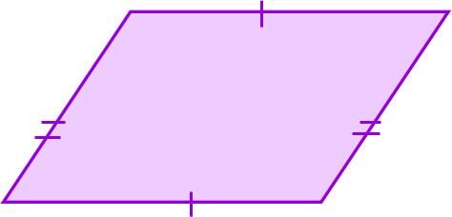
1. Is this figure a polygon?
Answer the questions below only if the figure is a polygon.
1a. Is this polygon concave or convex?
1b. Is this polygon regular, equiangular, equilateral, or none of these?
1c. What is the name of this polygon?

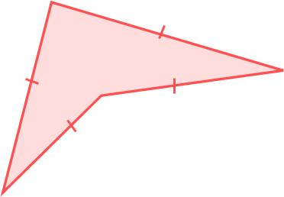
2. Is this figure a polygon?
Answer the questions below only if the figure is a polygon.
1a. Is this polygon concave or convex?
1b. Is this polygon regular, equiangular, equilateral, or none of these?
1c. What is the name of this polygon?

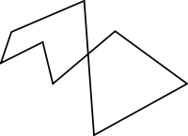
3. Is this figure a polygon?
Answer the questions below only if the figure is a polygon.
1a. Is this polygon concave or convex?
1b. Is this polygon regular, equiangular, equilateral, or none of these?
1c. What is the name of this polygon?

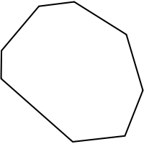
4. Is this figure a polygon?
Answer the questions below only if the figure is a polygon.
1a. Is this polygon concave or convex?
1b. Is this polygon regular, equiangular, equilateral, or none of these?
1c. What is the name of this polygon?

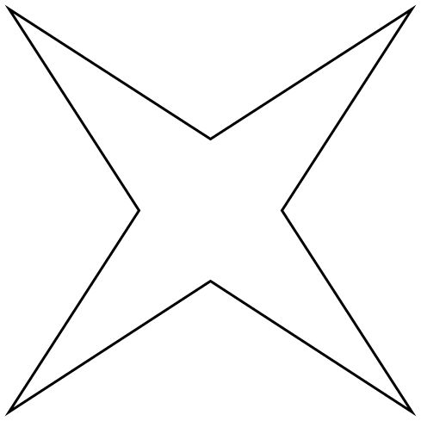 All sides are congruent.
5. Is this figure a polygon?
Answer the questions below only if the figure is a polygon.
1a. Is this polygon concave or convex?
1b. Is this polygon regular, equiangular, equilateral, or none of these?
1c. What is the name of this polygon?

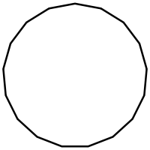 All sides and angles are congruent.
6. Is this figure a polygon?
Answer the questions below only if the figure is a polygon.
1a. Is this polygon concave or convex?
1b. Is this polygon regular, equiangular, equilateral, or none of these?
1c. What is the name of this polygon?

7. Identify which of these terms do not belong with the other three: square, circle, hexagon, or triangle. Explain your reasoning.

8. What are the coordinates of the vertices of the polygon formed by the lines in the diagram?
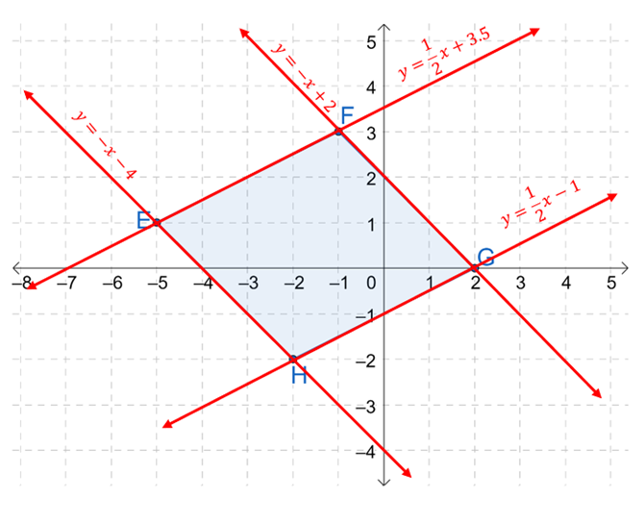
Coordinates: , , , and .

9. Find the coordinates of the vertices of the triangle formed by the lines: y = 8x − 3,
y = 2x − 3, and y = −x + 6. Show your work in the spaces provided.

The intersection of lines y = 8x – 3 and y = 2x – 3 is .
Show your work here:

The intersection of lines y = 8x – 3 and y = −x + 6 is .
Show your work here:

The intersection of lines y = 2x – 3 and y = −x + 6 is .
Show your work here:

The coordinates of the vertices of the triangle are: , , and .

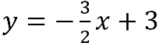
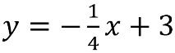
10. Use the link on the task page to find the coordinates of the vertices of the triangle formed by the lines: , , and y = x – 2. Copy and paste the graph in the space provided below. Then, answer the problems that follow.
Graph:

The intersection of lines and is .
The intersection of lines and y = x – 2 is .
The intersection of lines and y = x – 2 is .
The coordinates of the vertices of the triangle are: , , and .

